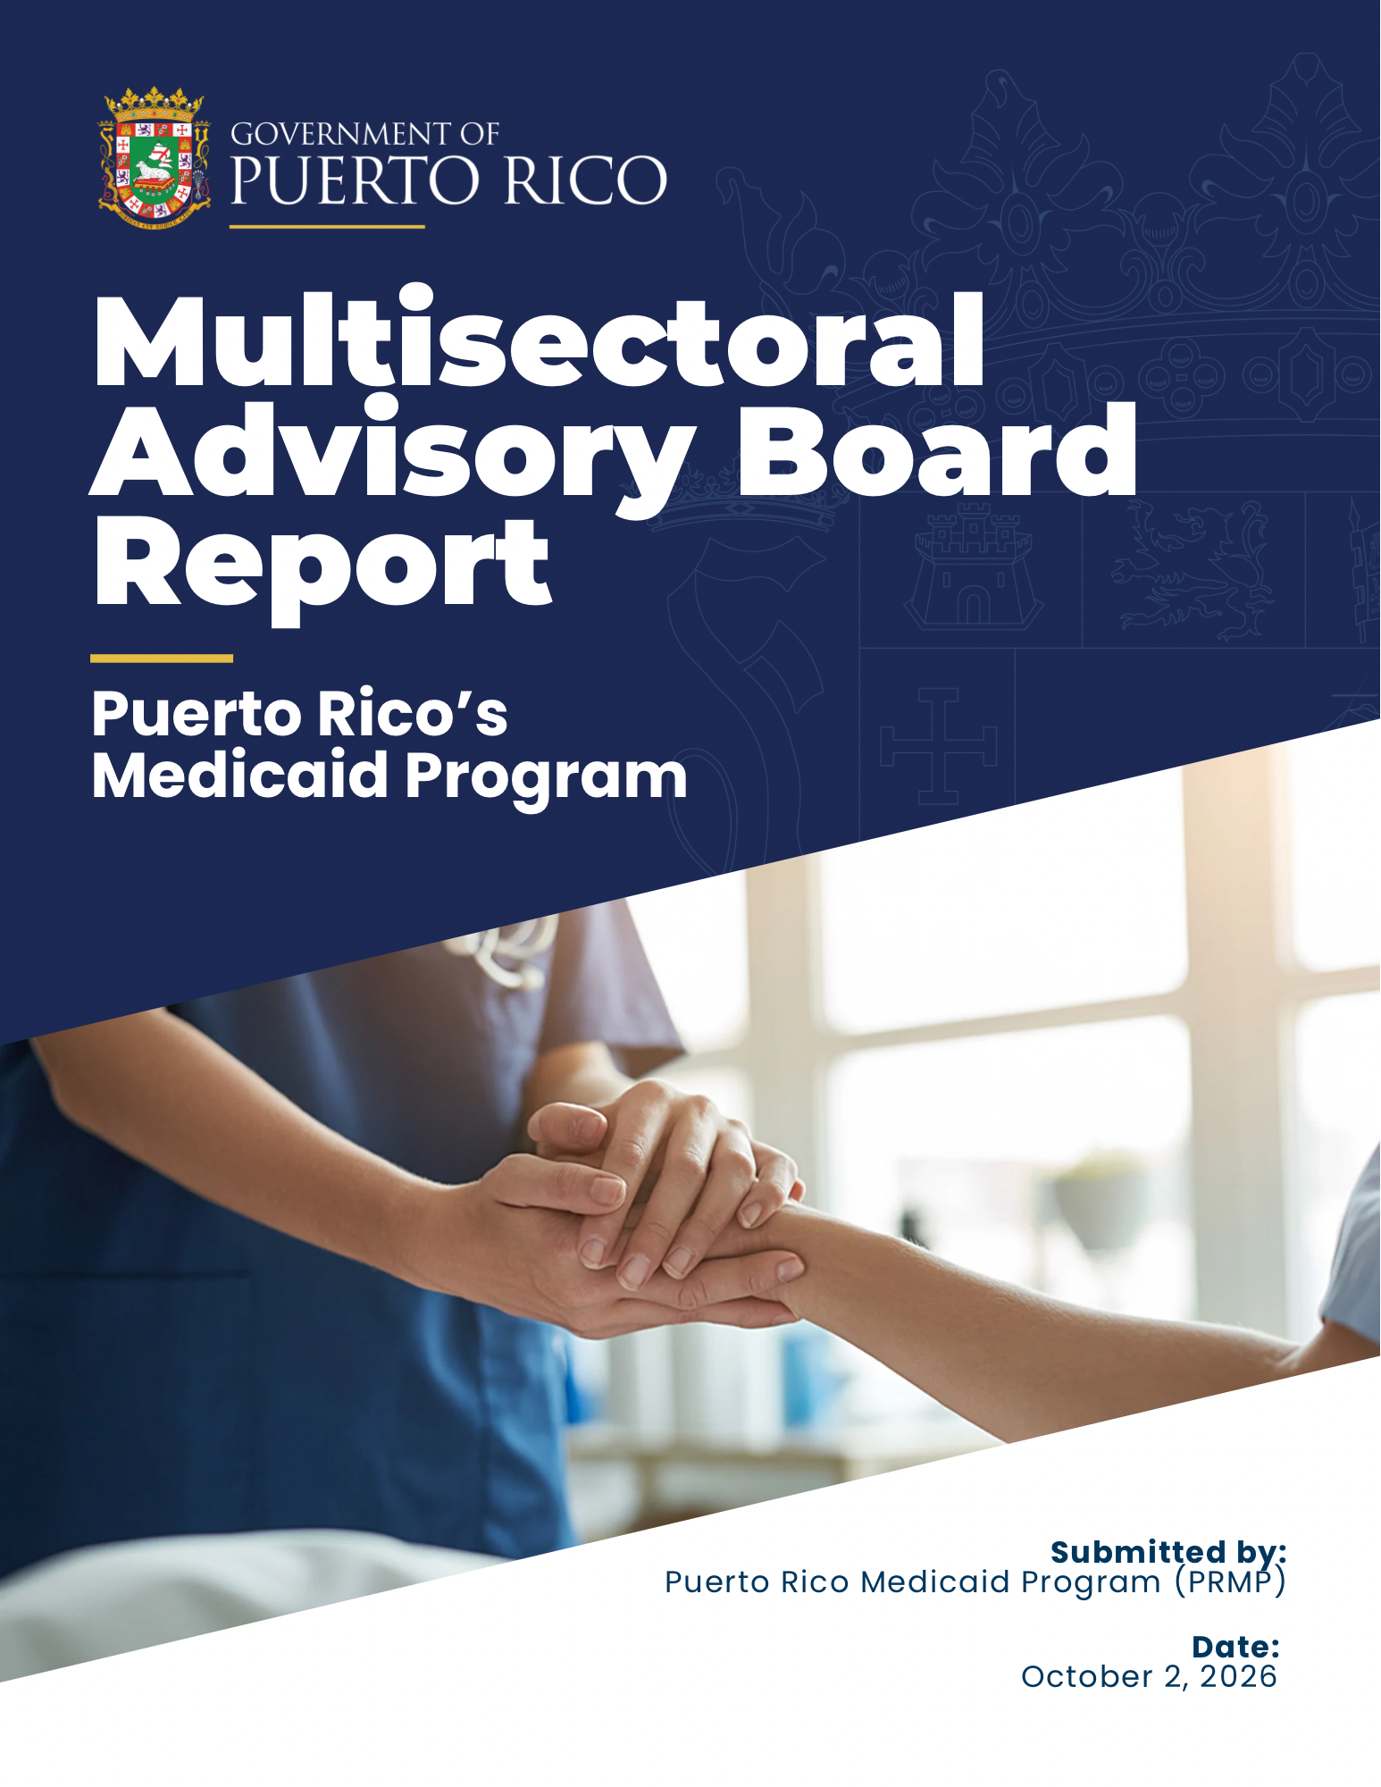

Table of Contents

Section Page

Overview 1
Executive Summary 1
Medicaid in Puerto Rico 4
PRMP and Population Served 4
Medicaid Population Needs 5
Aging Population 5
Chronic Conditions 8
Migration 12
Medicaid Funding Overview 18
FMAP and Capped Funds 18
Ongoing Funding Differences 21
Use of Enhanced Funding to Date 24
Improvements in Access and Quality of Care 27
Program Integrity and PRMP Compliance with Statutory Requirements 31
CAA, 2023 Requirements for Enhanced Funding 31
Recent Federal Medicaid Policy Changes 34
Consequences of Limited Funding 35
Projected Medicaid Spending Under Different Funding Scenarios and Their Effects 36
Medicare and Medicaid: Consequences for Puerto Rico's Health Care System……………………………………………………………………………………………………………………………………………….38
Medicare Advantage 44
Future Challenges of Medicaid Funding and FMAP 48
Puerto Rico's Unique Circumstances……………………………………………………………………………………50
Limited Ability to Generate Tax Revenue to Cover Local Share 52
Impact of FMAP and Allotment Reductions: A Funding Cliff 53
Congressional Engagement and Bipartisanship: 55
A United Front 55
Conclusion 56

Overview

In accordance with Governor Jenniffer González-Colón’s Executive Order 2026-006, establishing the Multisectoral Working Group to Ensure Fair and Equitable Funding for Federal Health Programs, this report provides an overview of the Puerto Rico Medicaid Program (PRMP), highlighting both recent progress and remaining structural challenges and supporting the case for sustained and enhanced federal Medicaid funding beyond federal fiscal year (FY) 2027.

The report incorporates multisectoral input from state agencies, providers, advocates, and additional stakeholders, and consolidates evidence‑based information reflecting Puerto Rico’s progress under the Consolidated Appropriations Act, 2023 (CAA 2023, P.L. 117-328), including compliance with statutory requirements, use of enhanced federal funds, and improvements to access, quality, eligibility, and program oversight. It includes information about the successful implementation of the Program Integrity Unit and the Procurement Division, required to receive additional funding.

The report also outlines the consequences of longstanding funding limitations, the risks posed by the potential funding cliff after FY 2027, and the importance of continued program stability to safeguard care for 40% of Puerto Rico’s population currently served by Medicaid. Lastly, it includes information about the ties that exist between the Medicaid and Medicare programs in Puerto Rico, mainly Medicare Advantage (MA), highlighting the need for administrative fixes or adjustments under MA to support portions of the Medicaid population.

The main objective is to provide a clear, data‑driven baseline for federal policy discussions concerning Puerto Rico’s Medicaid financing structure, the operation of the Social Security Act’s §1108 allotment ceiling, and alternatives for financing beyond FY 2027.

Executive Summary

PRMP plays a critical role in financing and delivering health care services to 40% of Puerto Rico’s population, including children, older adults, individuals with disabilities, and low-income working families. This report provides an overview of PRMP’s financing structure, the progress achieved through recent federal funding enhancements, and the persistent structural differences that place the program at risk as enhanced funding is set to expire after FY 2027.

Unlike the states, which receive open-ended funds to cover the federal portion for Medicaid, Puerto Rico receives an annual capped allotment under §1108(g) of the Social Security Act (SSA). Until September 30, 2027, PRMP is operating under the funding framework established by the CAA 2023, which temporarily increased the Federal Medical Assistance Percentage (FMAP) to 76% through FY 2027, from the statutory FMAP of 55%.

The CAA 2023 also provided additional funding increases to the annual capped allotment through FY 2027. These funding enhancements have provided limited interim fiscal stability and allowed for some program improvements, including the expansion of Medicaid eligibility through an increase in the Federal Poverty Level (FPL) threshold, expansion of covered services, and strengthened provider reimbursement. However, structural challenges remain that limit Puerto Rico’s ability to fully fund needed health care services.

This report was developed with input from a Multisectoral Advisory Board, including health care providers, community health centers, Managed Care Organizations (MCOs), beneficiary advocates, and Puerto Rico Resident Commissioner Pablo José Hernández. Advisory Board stakeholders emphasized the critical role Medicaid plays in maintaining access to care, supporting provider networks, and stabilizing Puerto Rico’s broader health care market, particularly for medically complex and high-need populations.

While contributors brought diverse perspectives and areas of focus, they were aligned on the challenges posed by Puerto Rico’s capped Medicaid financing structure and the risks associated with the impending 2027 funding cliff. This report reflects those shared themes related to Medicaid funding.

Stakeholders must work together to promote bipartisan Congressional action to:
      - Remove the allotment ceiling, consistent with state Medicaid programs, to provide adequate, sustained funding to Puerto Rico;
      - Utilize the same formula as the states to determine the FMAP, which would likely result in an FMAP of 83%. It is important to note that increasing the FMAP without increasing the allotment would result in Puerto Rico exhausting its allotment faster;
      - Include Puerto Rico in other federal programs from which it is currently excluded, like disproportionate share payments for hospitals to help address uncompensated or under-compensated care and, once sufficient funds are available, the Medicare Savings Program, which helps pay Medicare premiums and cost-sharing; and
      - Extend access to Long-Term Services and Supports (LTSS). Should sufficient funding not become available for Puerto Rico to establish LTSS island-wide, Congress could consider providing funds for a regional pilot program. This would allow the island to focus long-term care services in certain areas while still controlling federal spending.

Medicaid Funding Cliff Consequences

The change scheduled under current law after FY 2027 would reduce both Puerto Rico’s federal allotment and its FMAP relative to the temporary CAA 2023 framework, creating a situation where access and quality would be severely reduced. In summary, the Medicaid Funding Cliff will have the following consequences, among others, described in this report:
- FY2028: ~$500 million at 55% FMAP.
- Drop in federal funding of approximately $3.36 billion annually.
- An estimated 860,000 to 1 million beneficiaries could lose coverage.
- Uninsured rate to increase to approximately 30% (from 5.7% in 2024).
- Increased outmigration to the U.S. mainland, where health care services are more expensive, costing more to the federal government

If the goals in this report are achieved, Puerto Rico will be on a pathway to a more stable, accessible, and higher-quality health care system.

Medicaid in Puerto Rico

PRMP and Population Served

The Medicaid program provides health care coverage for a substantially larger share of Puerto Rico’s population than the national average. This makes the financing structure particularly consequential for program budgeting, provider participation, and health system capacity. Because Puerto Rico’s federal contribution is capped, decisions to expand eligibility, benefits, or reimbursement must be evaluated not only against the FMAP, but also against the remaining federal allotment. As a result, certain benefit categories that are mandatory or broadly available in the states remain unavailable or limited in Puerto Rico.

Puerto Rico uses an almost entirely managed care delivery system administered by the Puerto Rico Health Insurance Administration (PRHIA)/Administración de Seguros de Salud (ASES), which contracts with MCOs under the Plan Vital program to deliver health care services to Medicaid beneficiaries.
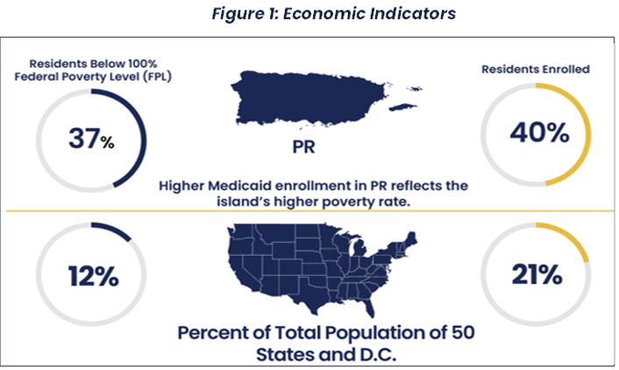

Figure 1: Puerto Rico’s Economic Indicators

Enrollees are distributed between “Plan Vital”, the island’s Medicaid managed care program, and “Plan Platino”, which is an integrated Dual Special Needs Plan (D-SNP) option operating in Puerto Rico for 20 years. ASES contracts with three Medicare Advantage Organizations (MAOs) to offer six plan options each. At present, approximately 307,000 beneficiaries, or 88% of residents who are dually eligible for Medicaid and Medicare with Medicare Parts A and B have chosen the Medicare Platino program to receive Medicaid benefits. The Medicare Platino program has been able to partially cover Medicaid benefit exclusions or gaps and health care needs of dual beneficiaries, like Non-Emergency Transportation and home care assistance, and help pay for the Part B member premium.

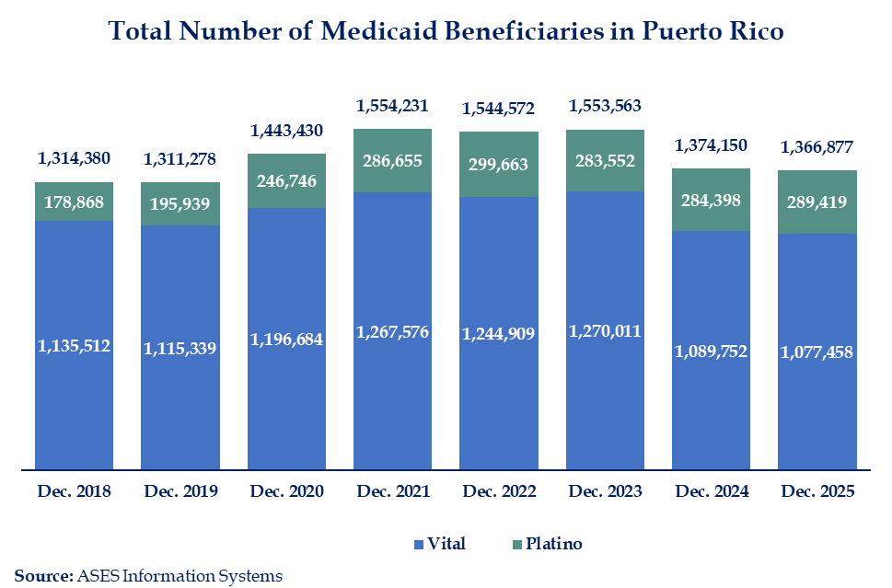

Figure 2: Total Number of Medicaid Beneficiaries in Puerto Rico
The Plan Platino population has grown significantly in recent years, driven by an aging population and high enrollment rates in Medicare Advantage (MA) plans. About 784,000 people in Puerto Rico are beneficiaries of Medicare, with over 680,000 of these enrolled in MA, representing the highest MA penetration rate in the nation.
The significant overlap between the Medicaid and Medicare populations in Puerto Rico is particularly important given the island’s demographic and health characteristics, discussed below, and the broader Medicare Advantage financing challenges addressed later in this report.

Medicaid Population Needs

Aging Population

Puerto Rico continues to face significant challenges driven by high rates of chronic conditions and sustained population decline. From 2010 to 2020, Puerto Rico’s population decreased by 11.8%. The 18 and over population decreased by 3.5% (97,591 people), and the population under 18 decreased by 37.9% (342,324 people).
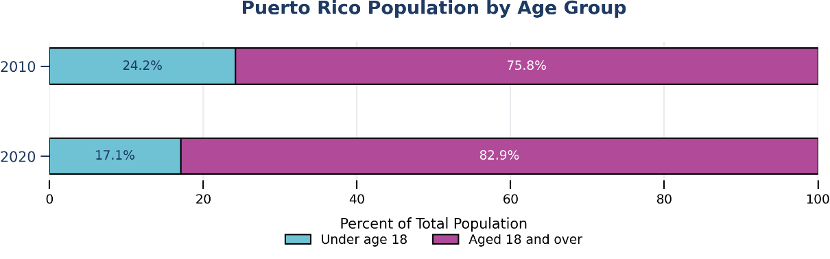
Figure 3: Puerto Rico’s Population by Age
Source: U.S. Census Bureau

Puerto Rico also has one of the most rapidly aging populations in the world, a trend driven by reduced birth rates and the outmigration of adults. These demographic and epidemiological trends contribute to growing challenges with access to care and system-wide strain as the Puerto Rico Medicaid Program works to support a population with growing levels and complexity of need.
Individuals age 65 and older represent a significantly larger share of the population in Puerto Rico than in the rest of the United States.
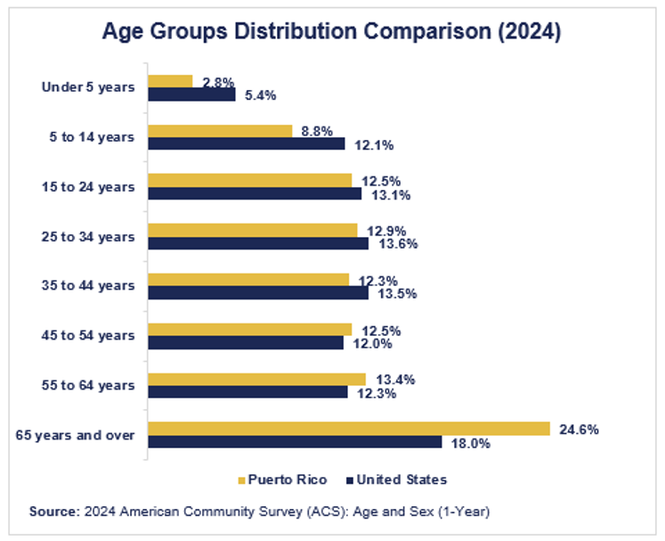
Figure 4: Age Groups Distribution Comparison (2024)
From 2014 to 2024, the oldest age group was the only cohort to experience growth, a trend projected to persist. As the population continues to age, demand for more intensive health care services is expected to continue increasing.
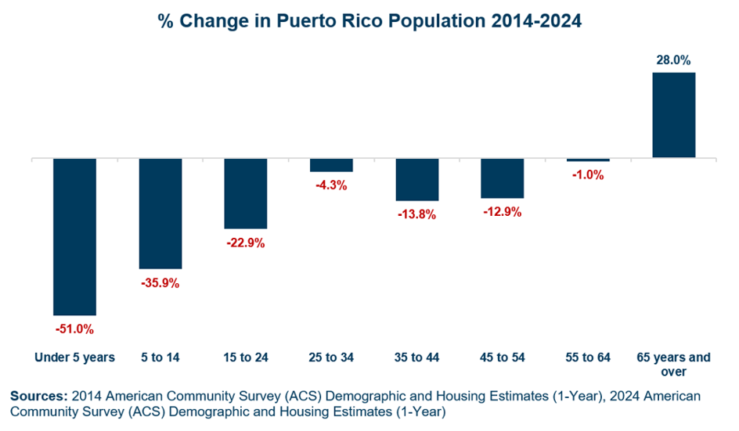
Figure 5: Percentage Change in Puerto Rico Population 2014 - 2024

Chronic Conditions

Puerto Rico shows disparities in numerous health indicators compared with other U.S. jurisdictions. The overall prevalence of many chronic diseases is higher, including asthma, cardiovascular disease, and diabetes.
As seen below, a larger share of individuals self-report their health status as fair or poor.
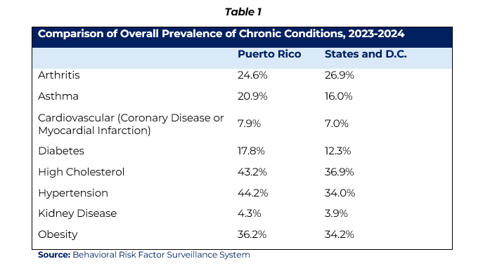

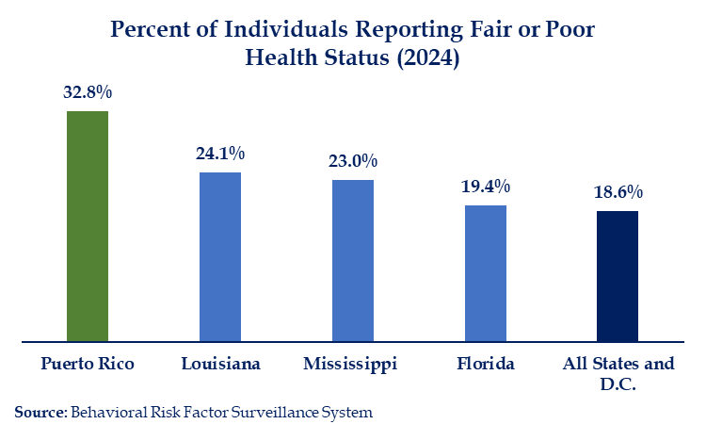
Figure 6: Percent of Individuals Reporting Fair or Poor Health Status (2024)

According to Behavioral Risk Factor Surveillance System (BRFSS) data from the U.S. Centers for Disease Control and Prevention (CDC), it is estimated that approximately 60% – 70% of Puerto Rico’s population has at least one chronic condition. Additionally, approximately 40% – 45% of adults have hypertension; about 16% have diabetes; 33%–36% have obesity; 35% – 40% have high cholesterol; and 6% – 8% have a history of cardiovascular disease. This level of chronic disease increases demand for care, making funding limitations particularly consequential for access, quality, and health outcomes.
Puerto Rico also has materially higher poverty rates than the national average. This is relevant to Medicaid financing because eligibility, utilization, and the island’s capacity to finance the non-federal share are all affected by household income and the size of the taxable income base.
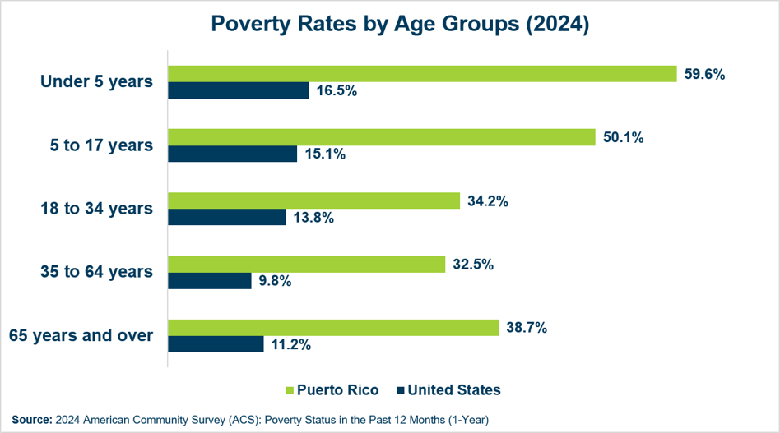
Figure 7: Poverty Rates by Age Groups (2024)
A benchmark of poverty levels in Puerto Rico, compared with those in some of the poorest states, highlights the challenges faced by Puerto Rico’s Medicaid program.

Table 2
Medicaid Benchmarks (2024)
State | % of Total Population Covered by Medicaid | Overall  Poverty Rate
Puerto Rico | 40.0% | 40.5%
Mississippi | 23.8% | 18.9%
Louisiana | 30.4% | 18.9%
New Mexico | 33.1% | 17.8%
West Virginia | 24.8% | 16.7%
Kentucky | 26.3% | 16.1%
Arkansas | 25.0% | 16.0%
Alabama | 19.9% | 15.6%
Oklahoma | 21.3% | 15.3%
United States | 20.4% | 12.5%
Sources: KFF estimates and U.S. Census Bureau ACS 5-year estimates

Children and adults with disabilities, including those with physical conditions, intellectual and developmental disabilities, serious behavioral disorders, and mental illness, are a particular group that relies heavily on Medicaid for health care services.

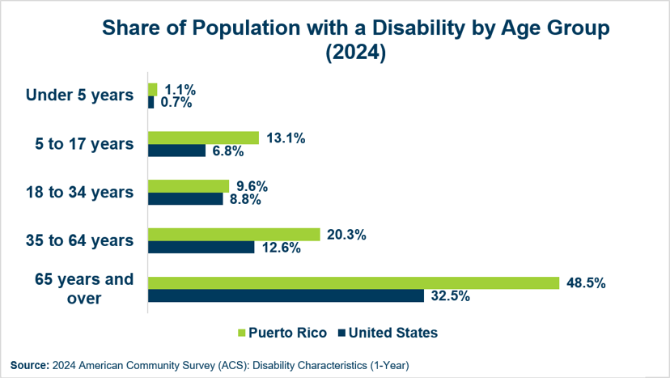

Figure 8: Share of Population with Disability by Age Group (2024)
In 2024, almost half of the Puerto Rico population with a disability was below 100% of the FPL. Yet, by statute, the Supplemental Security Income (SSI) is not available to American citizens who live in Puerto Rico. Instead, they receive supplemental assistance through the Aid to the Aged, Blind, and Disabled Program (AABD), a capped grant administered by the U.S. Department of Health & Human Services that applied to the States prior to the establishment of SSI. Puerto Rico must match 25% of the funds it receives from AABD, a requirement that does not apply to SSI.
Under the AABD, beneficiaries receive approximately $74 per month, compared to $994 for an individual, $1,491 for an eligible couple, or $498 for an essential person per month under the maximum 2026 amounts for SSI, which provides for a materially different level of benefit support.
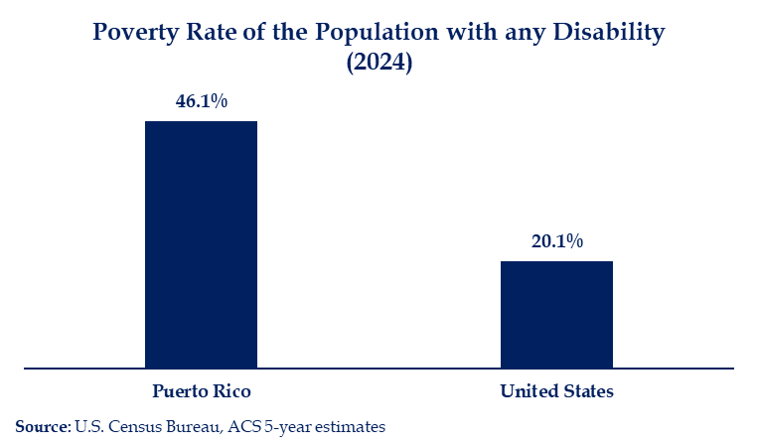

Figure 9: Poverty Rate of the Population with any Disability (2024)

The island has a medically complex population characterized by widespread poverty and an aging population, increasingly straining PRMP and the health care delivery system. These pressures are intensified by challenges with provider availability and access. While the number of licensed and actively practicing physicians in Puerto Rico has increased in recent years, reductions in certain medical specialties, uneven geographic distribution, variable Medicaid participation, and limited appointment availability continue to hinder access to care for Medicaid beneficiaries. These challenges are compounded by the ongoing outmigration of working-age adults.
Medicaid also offers critical support to cancer patients on the island. According to data from the Puerto Rico Central Cancer Registry, 81,407 individuals were diagnosed with invasive cancer in Puerto Rico between 2019 and 2023, including 42,449 men (52.1%) and 38,958 women (47.9%). Among men, prostate cancer was the most diagnosed cancer (39%), followed by colorectal cancer (11.1%) and lung and bronchus cancer (5.2%). Among women, breast cancer was the most diagnosed cancer (31.5%), followed by colorectal cancer (10.2%) and uterine cancer (10%).
During the same period, 26,419 cancer deaths were recorded in Puerto Rico, including 14,295 men (54.1%) and 12,124 women (45%). Among men, prostate cancer accounted for the largest share of cancer deaths (16.3%), followed by colorectal cancer (12.4%) and lung and bronchus cancer (11.7%). Among women, breast cancer accounted for the largest share of cancer deaths (17.6%), followed by colorectal cancer (11.8%) and lung and bronchus cancer (9.2%).
In 2023, an estimated 147,890 individuals were living with cancer in Puerto Rico, representing approximately 4.6% of the population. Moreover, between 2019 and 2023, 42% of patients diagnosed with cancer were covered by some form of Medicaid during the first year following diagnosis. This substantial Medicaid share underscores the program’s role in financing care for cancer patients in Puerto Rico, including access to diagnostic services, treatment, and ongoing disease management.
A material reduction in available Medicaid financing would require policy choices concerning eligibility, covered benefits, provider reimbursement, or additional local funding. This scenario would most certainly lead to an increase in Puerto Rico’s uninsured population and uncertainty for both beneficiaries and health care providers, resulting in severe adverse effects to the entire health care system in Puerto Rico and placing additional economic pressures in other states’ social support and health care systems.

Migration
Migration has been a central driver of Puerto Rico's sustained population decline over the past decade, with a large annual outflow of residents to the 50 states and Washington, D.C.
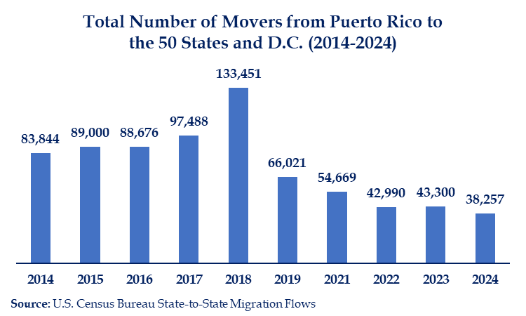

Figure 10: Total Number of Movers from Puerto Rico to the 50 States and D.C. (2014-2024)
Economic factors, such as employment opportunities and cost of living, are important determinants of outmigration, but health-related needs have also played a significant role in these decisions. A 2023 study by Ipsos surveyed 400 adults born in Puerto Rico who relocated to the mainland U.S. within the past 10 years. Findings show that 19% of respondents identified access to health services as one of their top five reasons for moving. Furthermore, 14% cited the need to treat health conditions as a primary motive.
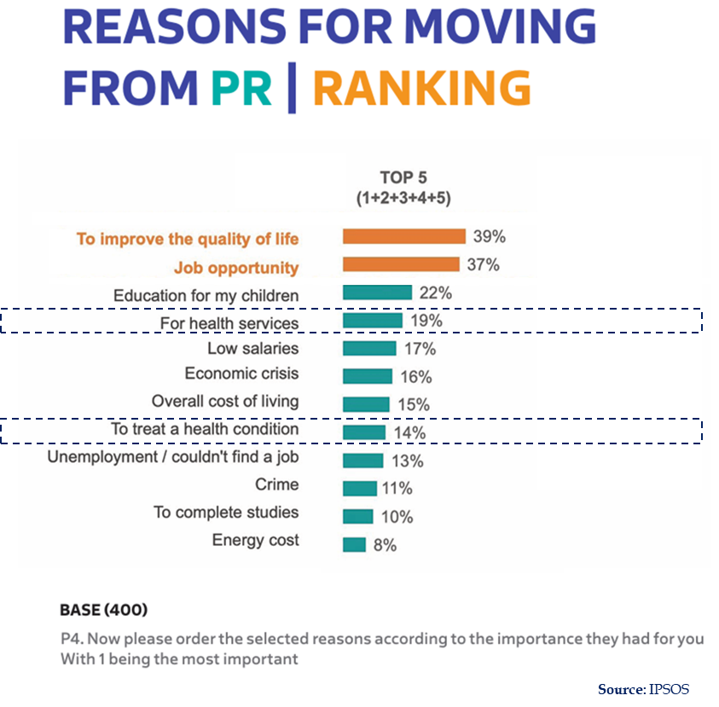

Figure 11: Reasons for Moving from PR | Ranking

The migration data indicate that health care access is one main factor reported by Puerto Rico residents who move to the states. These movement patterns are closely linked to the structural limitations that Puerto Rico’s health care system faces. Persistent shortages of specialized providers, limited availability of advanced procedures and treatment options, and long wait times for certain services create significant barriers to adequate care. Individuals with chronic health conditions, such as cancer or cardiovascular disease, and complex needs, such as orthopedic or neurological conditions, are particularly vulnerable. Because U.S. citizens who establish residence in a state may qualify for that state’s Medicaid program, migration can shift some Medicaid spending from Puerto Rico’s capped program to state programs financed under open-ended federal matching.

The Cost of Migration
Although the overall cost of living index in Puerto Rico is higher than the state average, largely due to elevated energy costs, health care services on the island are less expensive than on the mainland U.S.

Table 3
Source: Cost of Living Data Series | Missouri Economic Research and Information Center
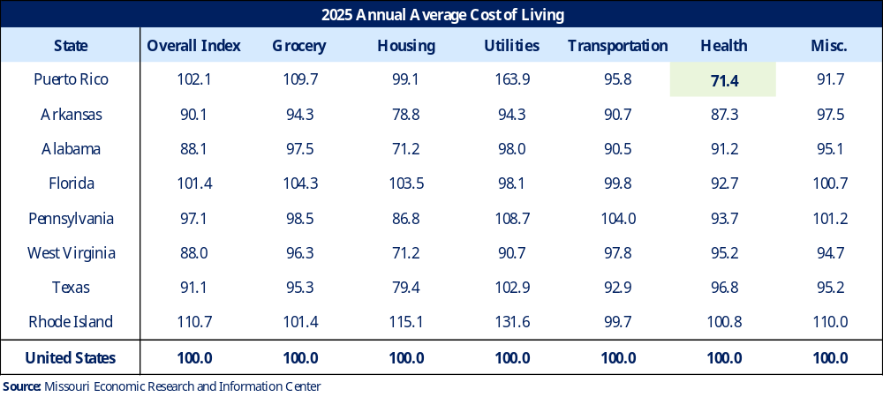
As Americans, residents of Puerto Rico are fully eligible to enroll in Medicaid upon establishing residency in any state. When Medicaid beneficiaries migrate, the cost of their care is absorbed by state programs, where benefit cost per enrollee is higher than in Puerto Rico. This shift increases both state-level obligations and federal expenditure through matching payments.
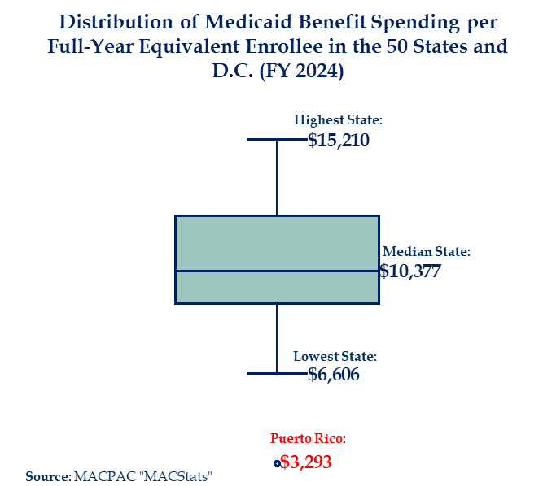
Source: EXHIBIT-23.-Medicaid-Benefit-Spending-per-Full-Year-Equivalent-Enrollee-for-Newly-Eligible-Adult-and-All-Enrollees-by-State-FY-2024.pdf
Figure 12: Distribution of Medicaid Benefit Spending per Full-
Year Equivalent Enrollee in the 50 States and D.C. (FY 2024)
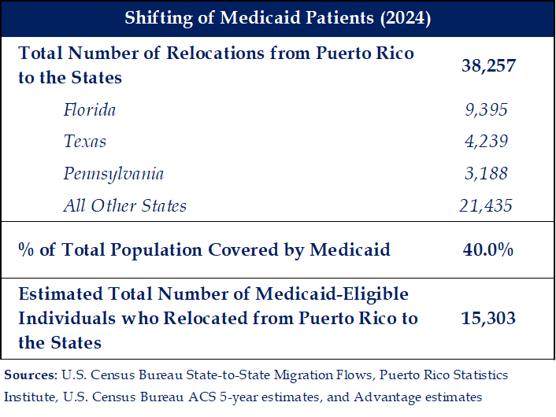

We estimated the number of Medicaid beneficiaries who may have relocated from Puerto Rico to the states in 2024 by applying Puerto Rico's Medicaid participation rate to the total number of individuals who relocated to each state. Specifically, because approximately 40% of Puerto Rico's population participates in Medicaid, we assumed for purposes of this analysis that the same proportion applies to the population relocating from Puerto Rico to the states.

Figure 13: Shifting of Medicaid Patients (2024)
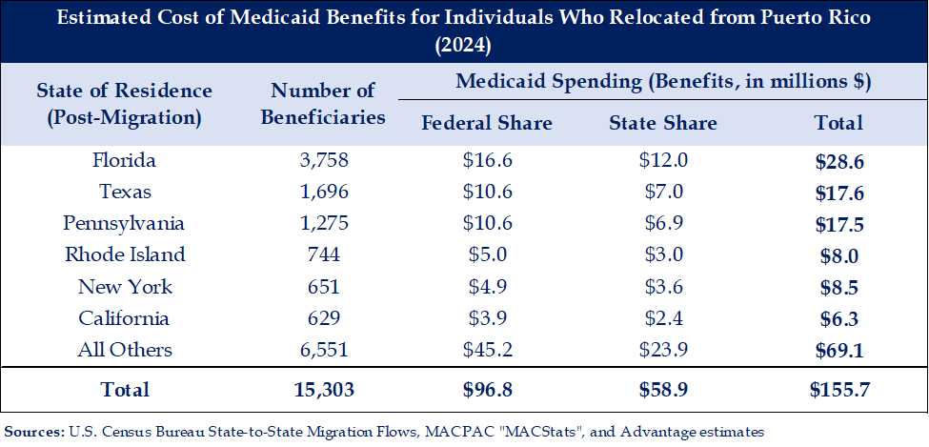

Based on this assumption, if similar migration patterns and Medicaid participation rates persist, more than 150,000 Medicaid beneficiaries could relocate stateside over the next 10 years. This estimate is consistent with prior research. A study published by the Center for Economic and Policy Research in 2017 estimated that 207,154 Medicaid recipients would migrate to the states over a ten-year period, assuming continuation of the prevailing outmigration trends at that time.
Using 2024 Medicaid benefit spending per enrollee, we further estimate that providing Medicaid coverage to this population of former Puerto Rico residents who relocated to the states could result in approximately $97 million in federal spending and $59 million in state spending. By comparison, providing Medicaid coverage to the same number of beneficiaries in Puerto Rico is estimated to result in approximately $49.1 million in federal spending.

Table 4
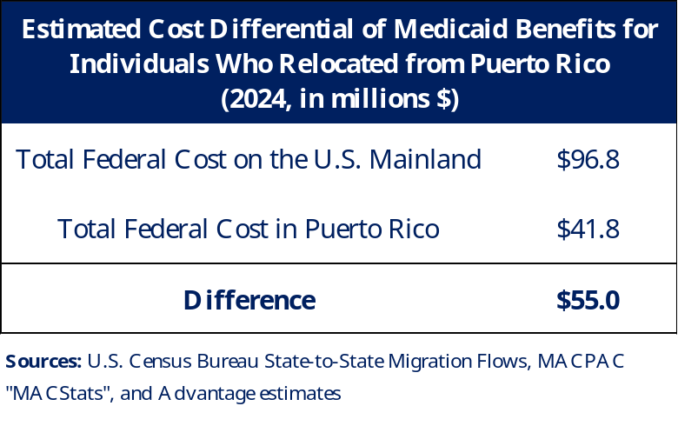
Sources: U.S. Census Bureau State-to-State Migration Flows, EXHIBIT-23.-Medicaid-Benefit-Spending-per-Full-Year-Equivalent-Enrollee-for-Newly-Eligible-Adult-and-All-Enrollees-by-State-FY-2024.pdf, and Advantage estimates

Table 5
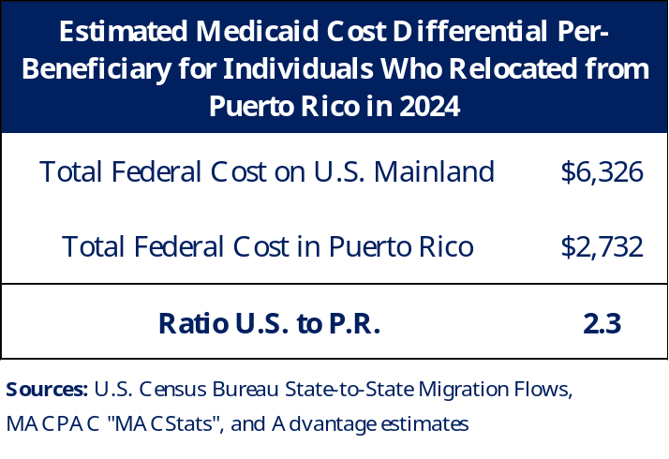
Sources: U.S. Census Bureau State-to-State Migration Flows, EXHIBIT-23.-Medicaid-Benefit-Spending-per-Full-Year-Equivalent-Enrollee-for-Newly-Eligible-Adult-and-All-Enrollees-by-State-FY-2024.pdf, and Advantage estimates
These estimates are for one year and do not account for the cumulative effects of ongoing costs of covering some Medicaid beneficiaries who migrated in prior years.
The migration analysis identifies a potential federal and state cost-shifting issue: Medicaid-eligible residents who move from Puerto Rico to a state may receive coverage in jurisdictions with higher average Medicaid spending per enrollee and open-ended federal matching. Thus, strengthening Medicaid financing in Puerto Rico can be viewed not only as an issue of equal access to care but as a cost-containment strategy for the federal government as states would otherwise assume the greater cost of patients moving from the island.

Medicaid Funding Overview

FMAP and Capped Funds
The Federal Medical Assistance Percentage (FMAP) is the federal contribution to state and territory Medicaid agencies. Unlike the states, which receive open-ended Medicaid funds, Puerto Rico receives an annual capped allotment set forth by §1108(g) of the Social Security Act (SSA) and a statutorily set FMAP.
The PRMP currently receives Medicaid funds through the CAA 2023, which extended a 76% FMAP through FY 2027, an increase from the 55% FMAP set by §1905(b) of the SSA. The CAA 2023 also provided gradual increases to the annual capped allotment through FY 2027. These funding enhancements have provided interim fiscal stability, allowed Puerto Rico to maintain limited program improvements and make foundational investments, including expanding services and eligibility and supporting provider participation. Yet, despite the enhanced allotments and increased FMAP, the structural differences remain, limiting Puerto Rico’s ability to fully fund the health care services needed.
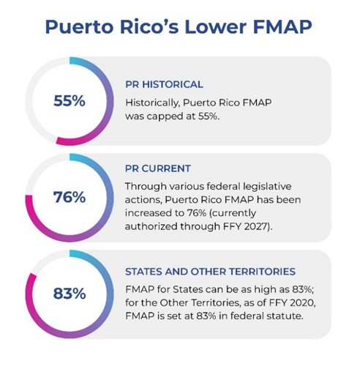

Figure 14: Puerto Rico’s FMAP

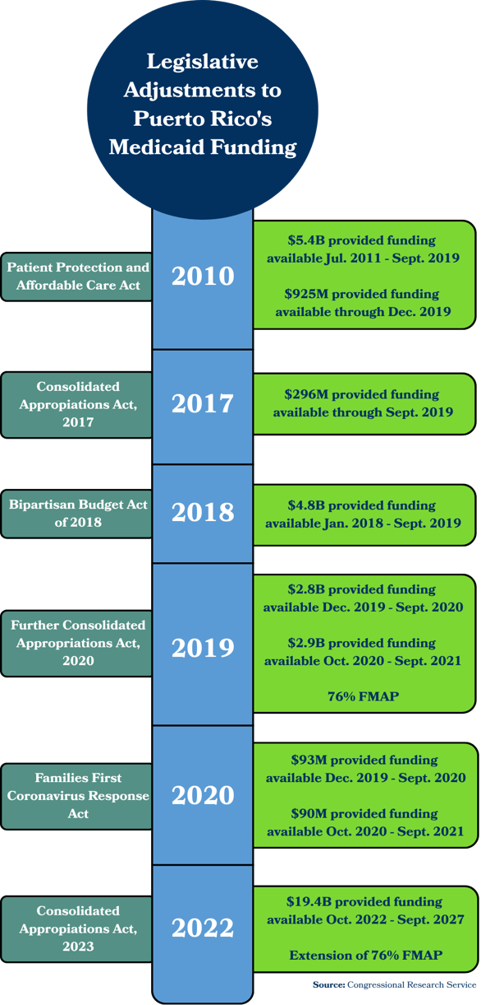
Figure 15: Legislative Adjustments to Puerto Rico's Medicaid Funding

Medicaid in Puerto Rico is currently funded through the following combination of federal and local revenue streams:

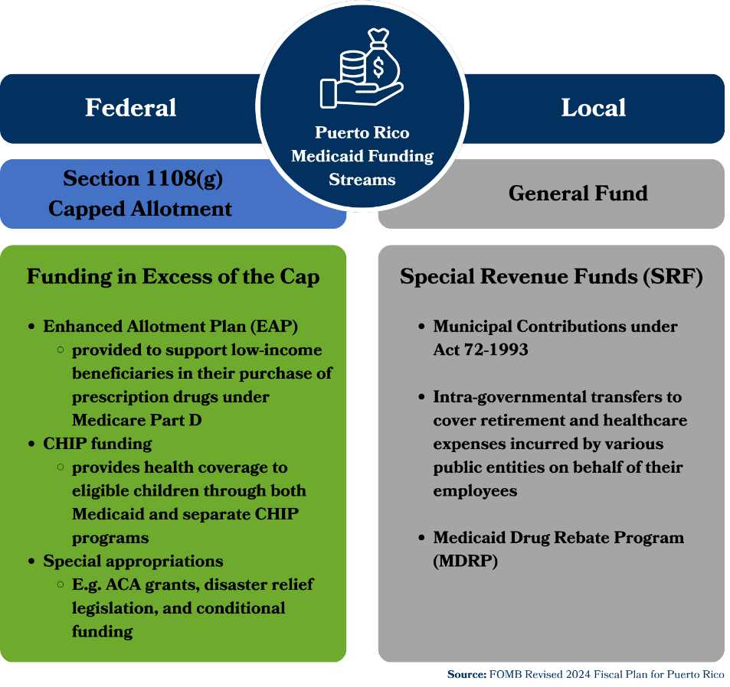

Figure 16: Puerto Rico Medicaid Funding Streams
Section 5101 of the Consolidated Appropriations Act, 2023 (CAA, 2023) includes the most recent federal funding agreement for Puerto Rico’s Medicaid program, covering FY 2023 through FY 2027, for the following amounts:
- FY 2023- $3,275,000,000
- FY 2024- $3,325,000,000
- FY 2025- $3,475,000,000
- FY 2026- $3,645,000,000
- FY 2027- $3,825,000,000

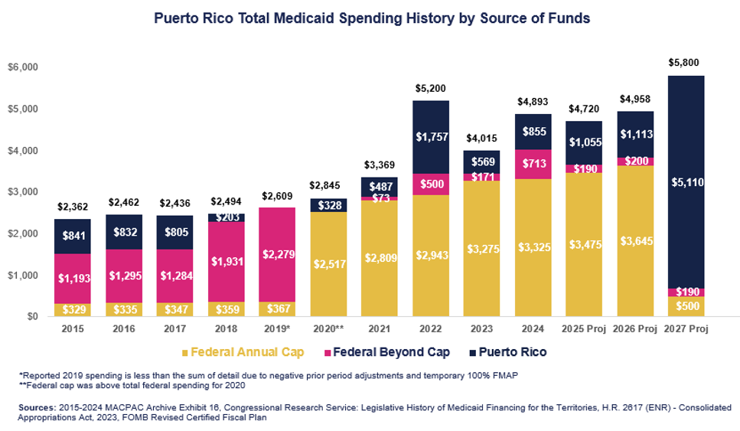

Figure 17: Total Medicaid Spending by Source of Funds
The annual federal cap and 55% FMAP impose significant pressure on the government of Puerto Rico to cover a disproportionately large share of its Medicaid spending. Some of this pressure has been alleviated through special appropriations, enhanced federal allotments, and the elevated 76% FMAP the island has received since FY 2020.

Ongoing Funding Differences

Federal Capped §1108 Allotment

Because of the annual §1108 capped allotment, Puerto Rico can only access federal dollars up to the allotment ceiling, making it increasingly difficult to sustain recent program enhancements while trying to address remaining eligibility and coverage gaps. If Puerto Rico exhausts its capped allotment, it must fund its Medicaid operations using only state funds.

Using expenditures from FY 2025 and applying the average annual increase between FY 2023 and FY 2025, Puerto Rico estimates expenditures for FY 2026 and 2027 to exceed its annual federal capped allotment.

Table 6: State and Federal Actual and Projected Expenditures FY 2023 – FY 2027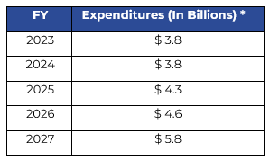
*Expenditures are actual through the third quarter of FY 2025 (June) and projected for
the fourth quarter of FY 2025 (July–September). These figures combine federal and
state fund contributions. The 2026 and 2027 amounts are projected.

Removing the §1108 allotment ceiling would align Puerto Rico with the states on the basic principle that allowable Medicaid expenditures receive the applicable federal match without a separate annual territorial ceiling and would allow for adequate, sustained funding to the island.

Past increases in Medicaid funding have had a direct and measurable impact on the scope and quality of health care services available in Puerto Rico. They have enabled the Medicaid program to expand into critical areas of care that are standard in the mainland U.S. Notably, increased funding enabled expanding coverage to include home health, durable medical equipment (DME), hospice, and non-emergency medical transportation (NEMT).
However, even as services expand, health care providers in Puerto Rico are under pressure. Insufficient Medicaid funding would bring this issue to a head. For example, island hospitals may not be fully compensated by the government, causing significant financial challenges.

Figure 18 describes the financial position of Puerto Rico hospitals, including government-operated facilities and the Island’s only trauma hospital, as compared with similar stateside facilities.

Figure 18: Hospital Net Profit Margin
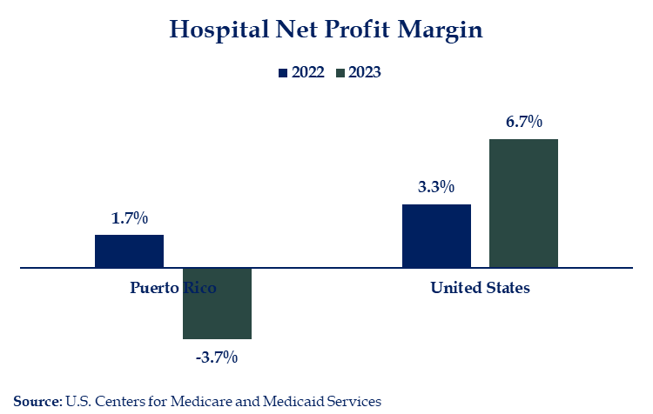

Insufficient funding under Medicaid has impacted the financial condition of Puerto Rico’s health sector, which has been under greater pressure compared with the rest of the United States.

Table 7

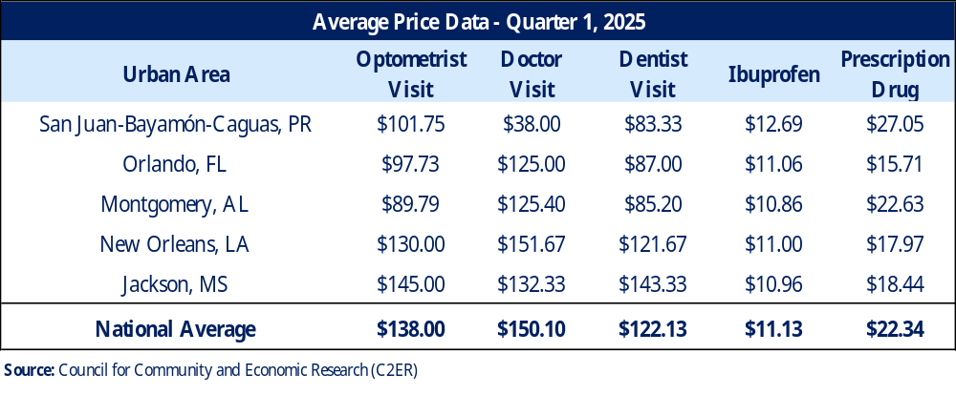

Under current law, the enhanced allotments and elevated 76% FMAP are both to be significantly reduced in FY 2028 and subsequent years. This will have profound implications for beneficiary coverage, provider reimbursement, and the overall stability of the health care system and the general economy. Removing the federal allotment ceiling and applying the state FMAP formula would replace the current Puerto Rico-specific financing rules with the basic matching structure used in the states; prior MACPAC and GAO analyses estimate that the state formula would place the island at the 83% statutory maximum.

Table 8

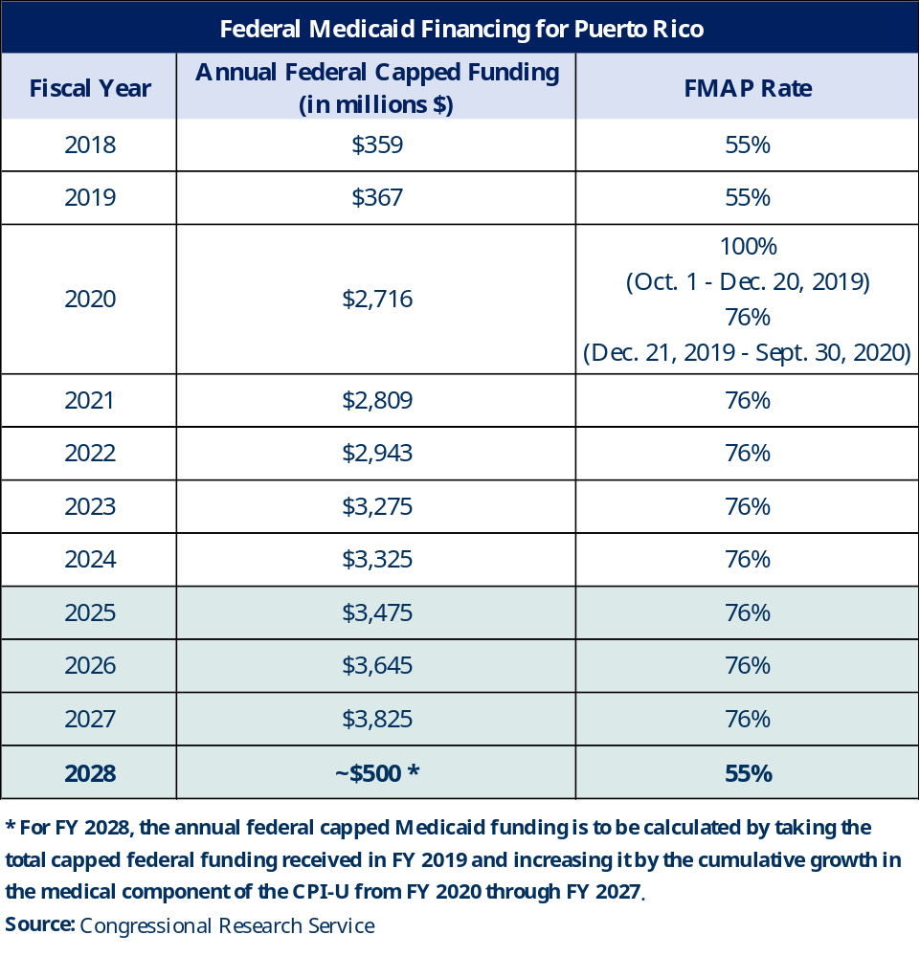

* By meeting program integrity and other requirements, Puerto Rico has also received an annual increase of $375 million. This brings the total amount for FY 2027 to $4.2 billion.

Use of Enhanced Funding to Date
**Service descriptions and terminology for the following tables have been simplified and adapted from the official Centers for Medicare and Medicaid Services (CMS) framework to improve readability. The table does not replicate CMS terminology or classifications verbatim.**
Mandatory Services
Service | Puerto Rico | States
Transportation to Medical Care
Inpatient Hospital Services
Outpatient Hospital Services
Rural Health Clinic Services
Federally Qualified Health Center Services
Laboratory and X-ray Services
Nursing Facility Services
Early and Periodic Screening, Diagnostic, and Treatment
Family Planning Services
Tobacco Cessation Counseling for Pregnant Women
Physician Services
Home Health Services (including Durable Medical Equipment and Supplies)
Nurse Midwife Services
Certified Pediatric and Family Nurse Practitioner Services
Freestanding Birth Center Services
Medication Assisted Treatment
Routine Patient Costs of Items and Services for Beneficiaries Enrolled in Qualifying Clinical Trials
Concurrent Care for Children Receiving Hospice

**At this time, Puerto Rico's Medicaid program does not cover long-term services and supports (LTSS) in home and community-based settings, including personal care services for older adults and individuals with physical disabilities, nor does it provide residential or community-based services for individuals with intellectual and developmental disabilities or serious behavioral health conditions. Lastly, it does not have a Medicaid Expansion population and does not operate a Medicare Savings Program due to limited funds. **
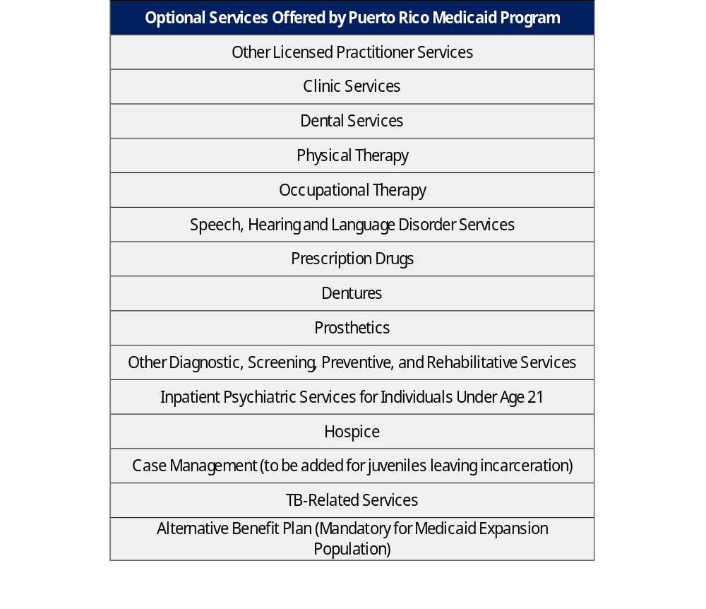

Expansion of Service Coverage
Puerto Rico continues efforts to finance services added in 2024, including home health, durable medical equipment (DME), hospice, and non-emergency transportation (NEMT). These services increase expenditures charged against the annual capped allotment, making the size and predictability of the federal ceiling directly relevant to whether Puerto Rico can sustain these benefits over multiple fiscal years.

Table 9

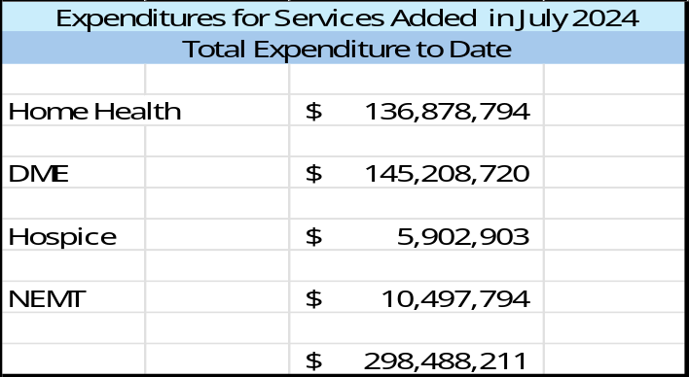

These services are particularly important considering Puerto Rico’s growing elderly population. As island residents age, access to these services is increasingly necessary to support continuity of care, improve health outcomes, and reduce pressure on hospitals and other institutional settings.

Expansion of Eligibility

Increased funding appropriated by the CAA 2023 has allowed Puerto Rico to implement eligibility policy changes that support Medicaid coverage for low-income individuals. These changes include increasing the eligibility level used for Medicaid to 100% of the FPL. Prior to the CAA 2023, the island had to use the local poverty level (LPL) for eligibility purposes due to financial limitations, which meant residents needed to have lower incomes to qualify for Medicaid than residents of the states.

Puerto Rico also expanded coverage to Former Foster Care Children (FFCC), implemented 12-month continuous eligibility for children, and added eligibility protections for a spouse who applies for Medicaid. The PRMP continues to look for opportunities to enhance coverage opportunities and improve the eligibility experience for individuals applying for Medicaid coverage.

Improvements in Access and Quality of Care

Quality Measurement

Puerto Rico continues to evaluate coverage policy and strengthen collaboration with state and federal partners to support program administration, quality measurement, and compliance decisions.

Implementation of reporting on Child and Adult Core Sets marks a significant milestone in program monitoring and quality improvement efforts. In compliance with federal requirements, Puerto Rico has submitted its Medicaid and Child and Adult Core Sets reports, continuing its commitment to align with federal expectations. These reports can be used to understand factors affecting the overall quality of Medicaid services.

The Puerto Rico Health Insurance Administration (PRHIA) continues to require annual reports from MCOs on the Healthcare Effectiveness Data and Information Set (HEDIS). HEDIS measures are a set of standardized performance indicators used to assess the quality of care and services provided by the MCOs. Puerto Rico uses HEDIS data to monitor outcomes, guide quality improvement initiatives, and support care programs. The combination of Core Sets and HEDIS reporting assists PRHIA with monitoring and evaluating the MCO operations and the corresponding services rendered by providers.

In addition, PRHIA uses the Health Care Improvement Program (HCIP) to monitor and evaluate the MCOs. A portion of each MCO premium is retained and placed in a Retention Fund, the distribution of which is driven by MCO performance on selected quality and efficiency indicators.

Data from these reporting efforts reflect challenges and areas of focused improvement used to guide future initiatives as Puerto Rico remains committed to promoting transparency.

Medicaid Enterprise System (MES)

The PRMP continues to focus on investing in the modernization of technology systems to improve oversight, integration, governance, accountability, and federal compliance.

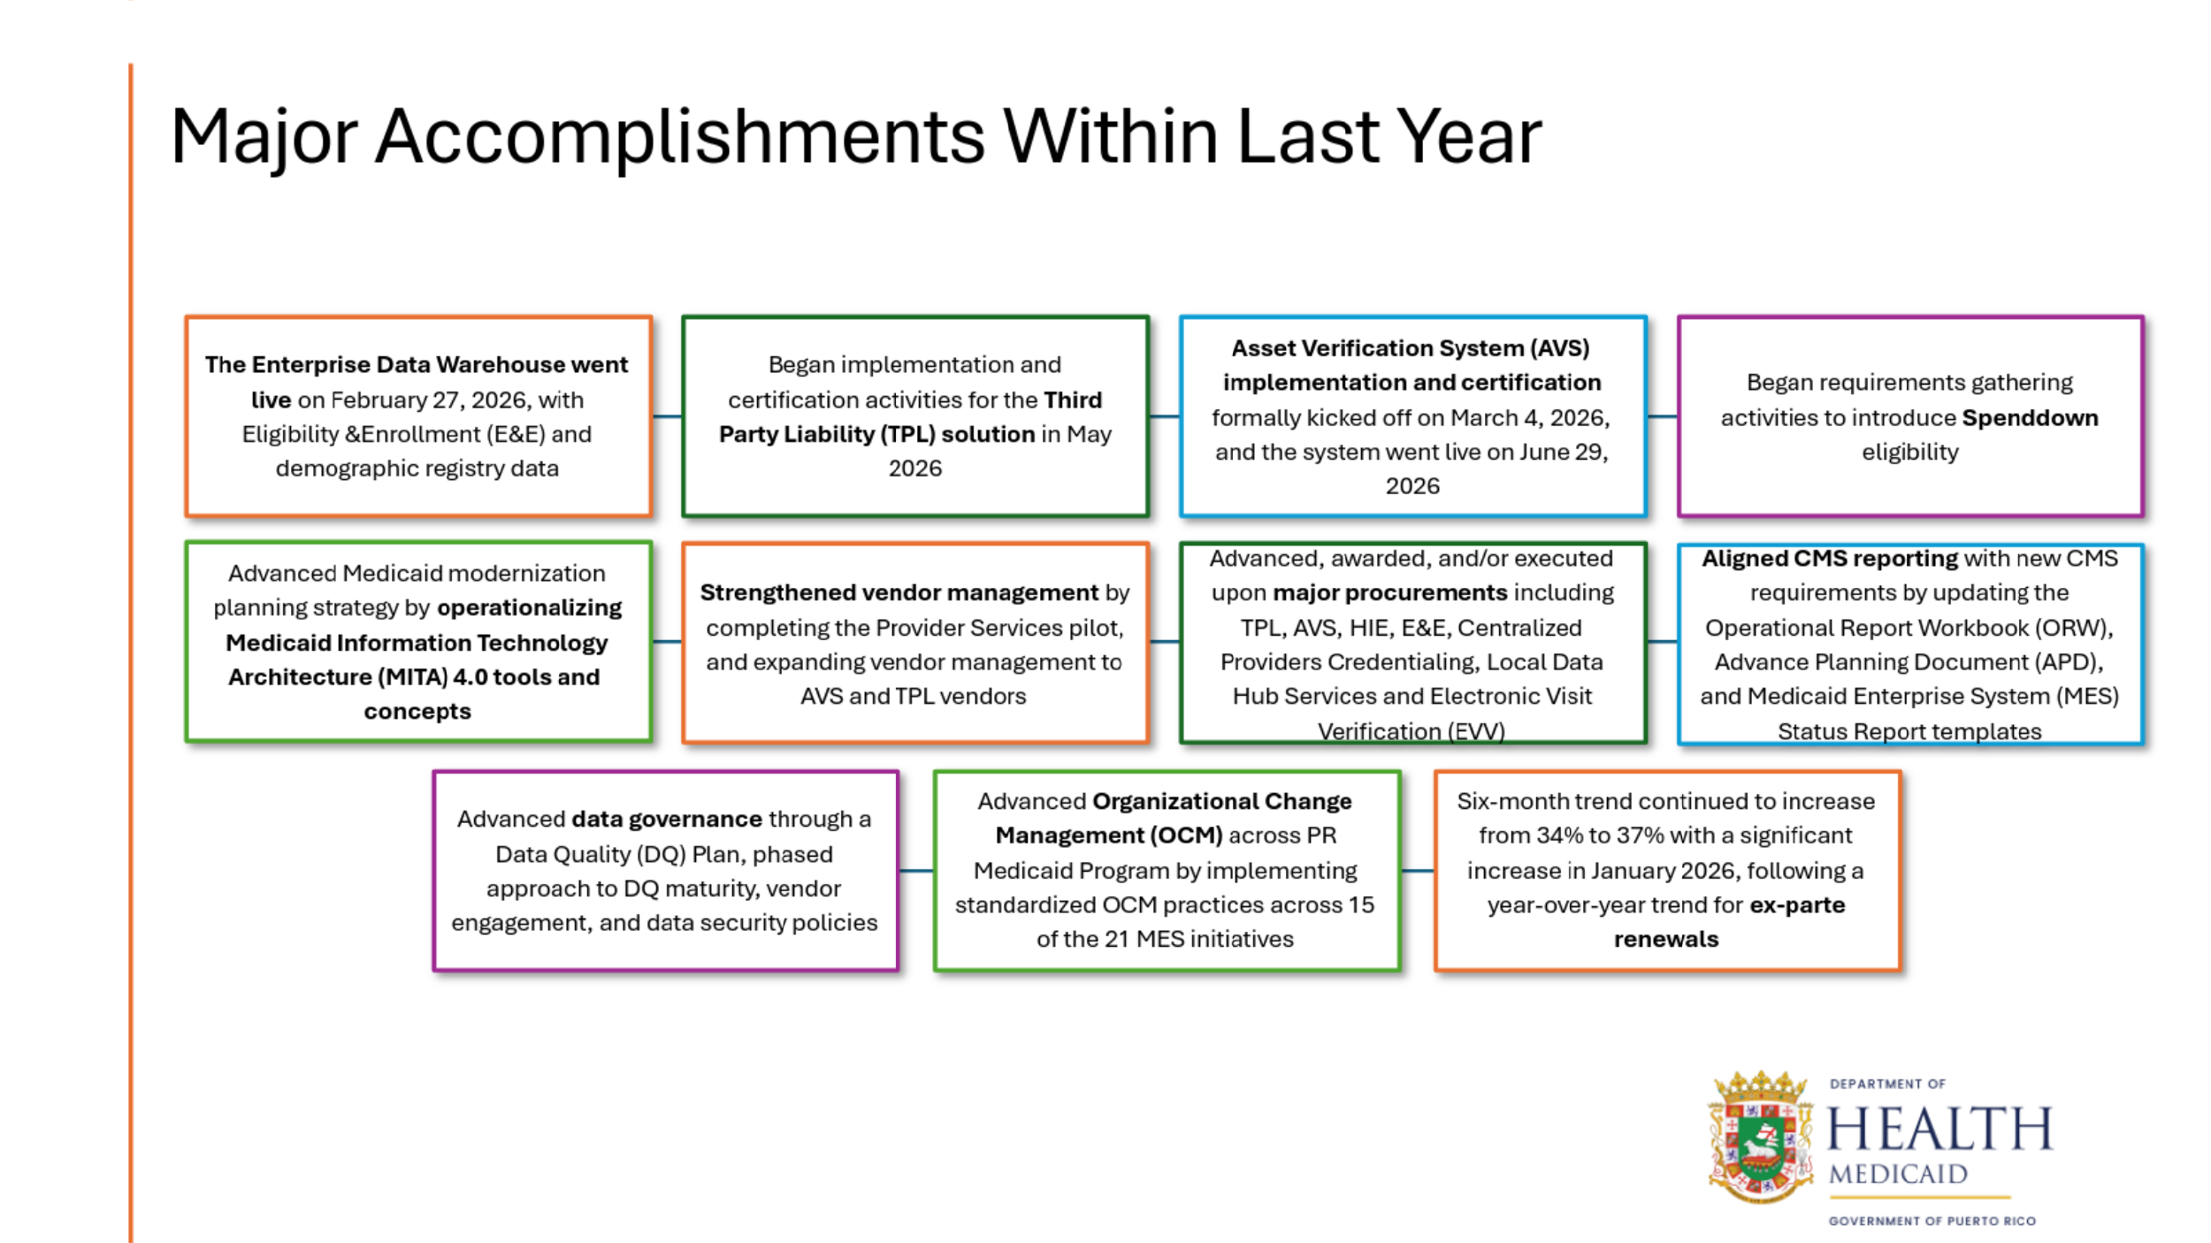

The PRMP is participating in the Centers for Medicare and Medicaid Services (CMS) pilot of the proposed Medicaid Information Technology Architecture (MITA) 4.0 and has helped evaluate new approaches for connecting business needs, modernization investments, program outcomes, and enterprise governance. Puerto Rico applied these concepts to support outcome-based planning, maturity assessments, capability modeling, and long-term Medicaid Enterprise System (MES) planning.

These actions have helped promote greater technology integration with CMS and better tracking of patient services and data. As such, the PRMP continues to align with federal priorities related to Medicaid governance, program integrity, interoperability, data-sharing capabilities, workforce development, and strategic planning.

While these themes support requirements and expectations established through the CAA 2023, PRMP's broader focus remains on strengthening accountability, operational excellence, and the long-term sustainability of Medicaid services in Puerto Rico.

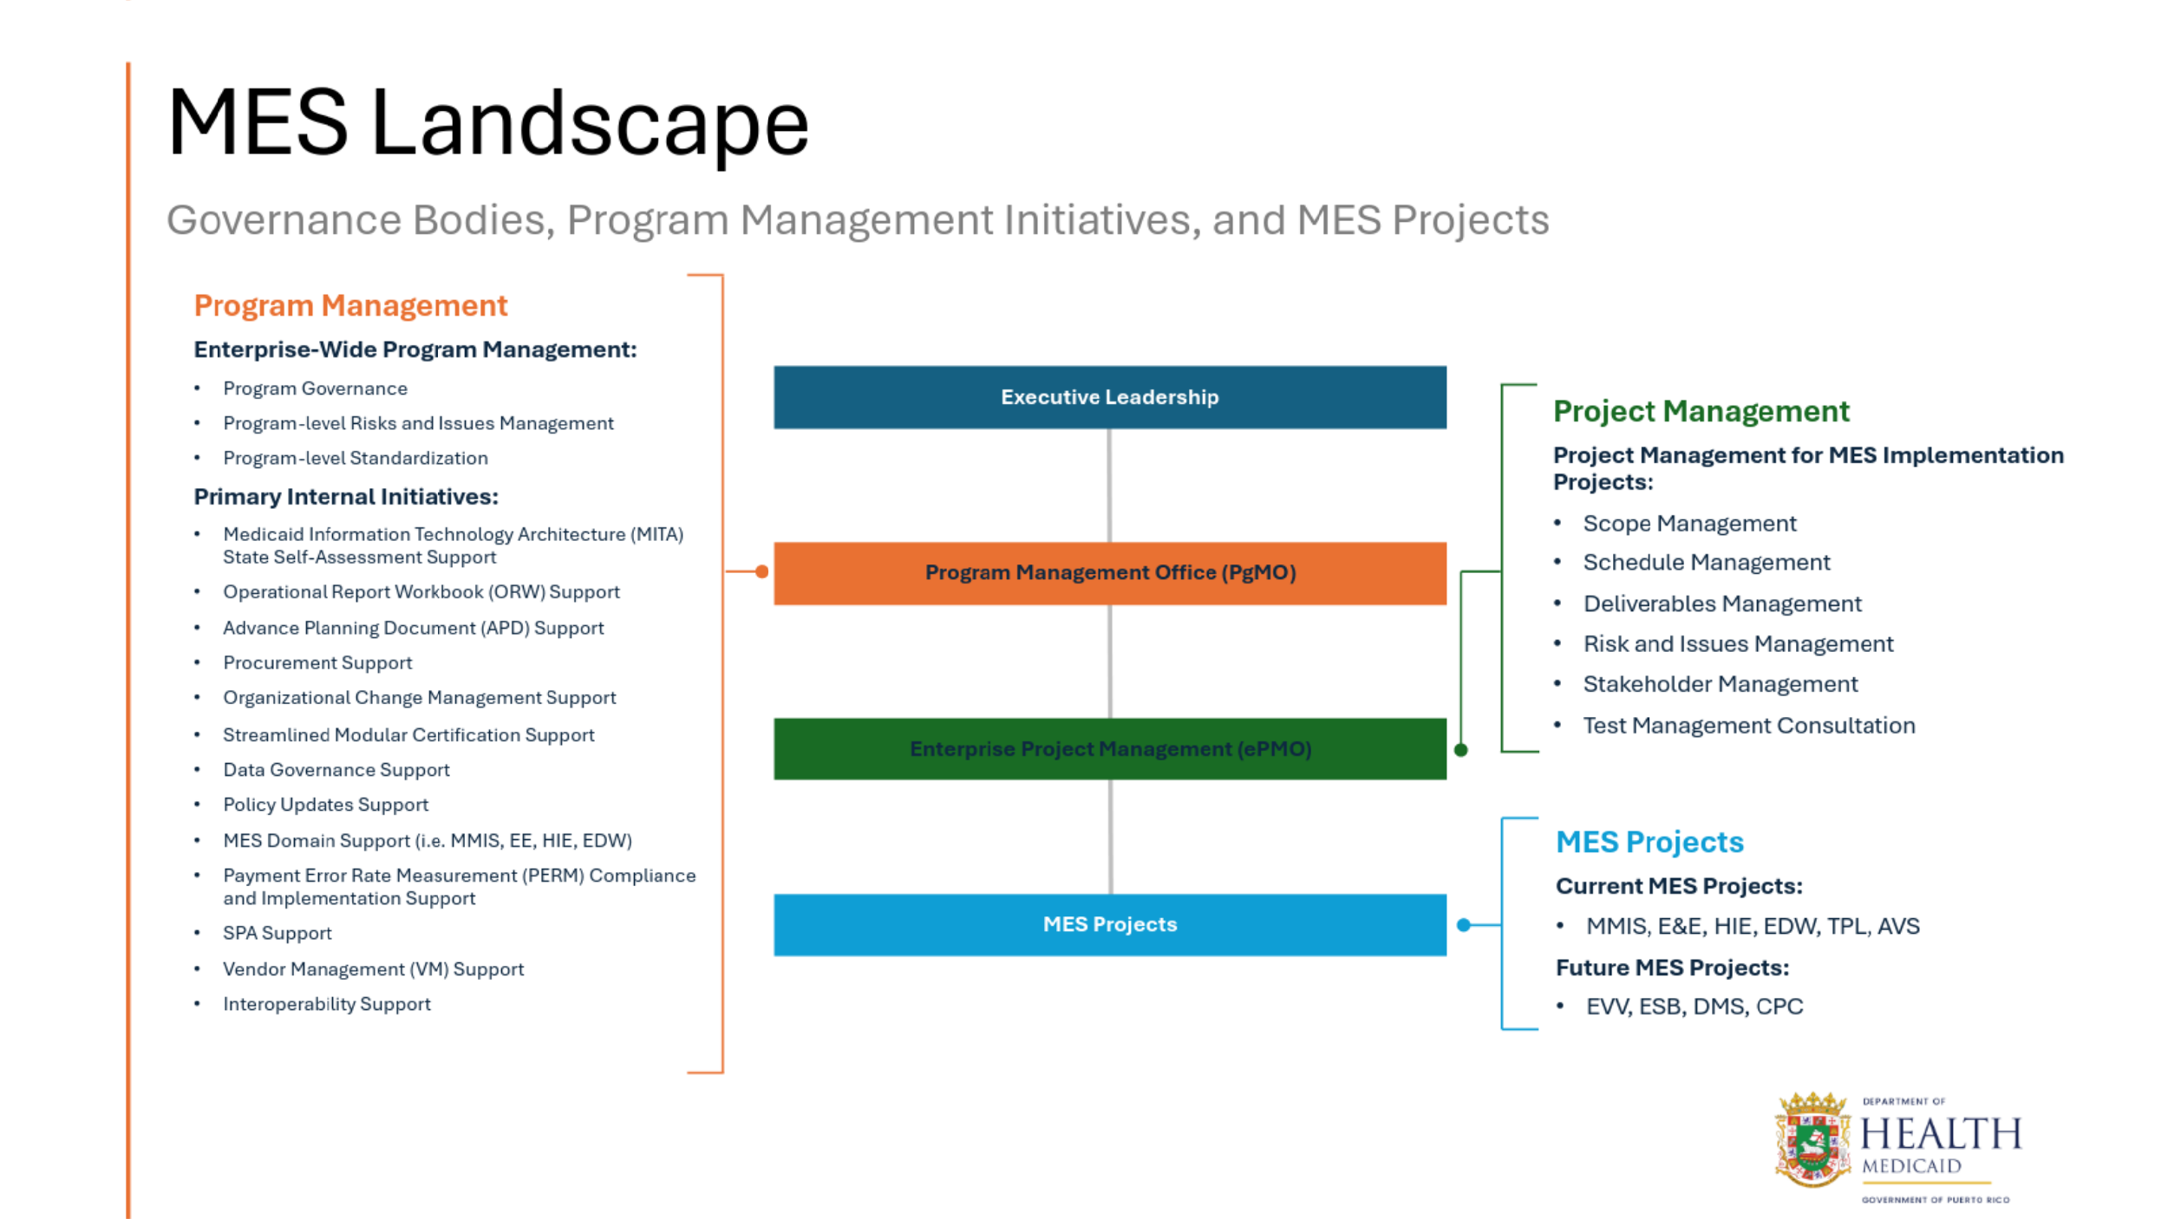

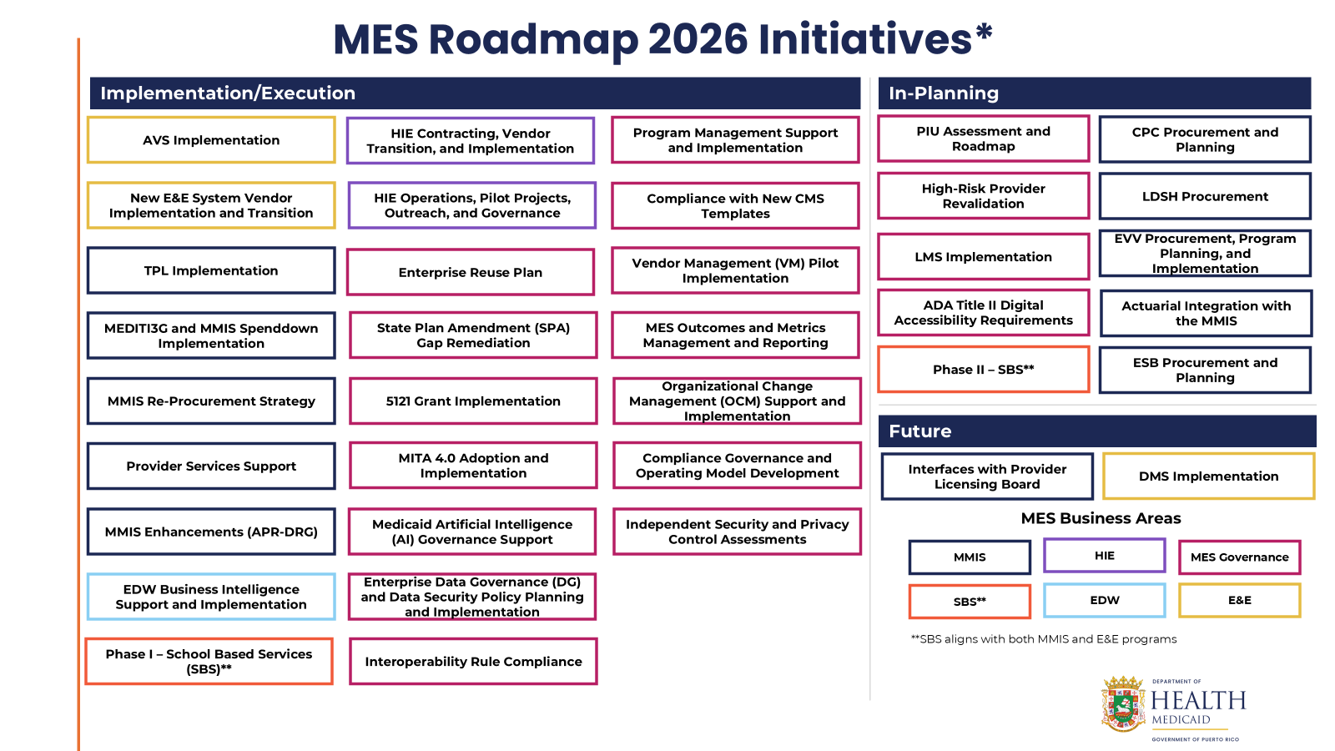

Enhanced Provider Reimbursement

To secure sufficient providers and in conformance with CAA 2023 requirements, Puerto Rico has implemented several increases to provider reimbursements to improve beneficiary access. These actions have been supported in part by $300 million per year in additional federal funding associated with the physician fee schedule increase and include the following:
- The minimum Medicaid reimbursement for physician services under the Plan Vital managed care program increased from 70% to 75% of the Medicare Part B fee schedule in January 2023, consistent with the requirements of the CAA 2023. In 2024, the Financial Oversight and Management Board for Puerto Rico (FOMB) approved a further increase to 100% of the Medicare Part B fee schedule, retroactive to October 1, 2023, which is the minimum reimbursement level currently in effect.
- In January 2023, Puerto Rico increased the minimum reimbursement for behavioral health services from 70% to 80% of the Medicare Part B fee schedule. Enhancing minimum reimbursement helps standardize reimbursement across MCOs and engage a provider network.
- After evaluating reimbursement information from other payers, a revised minimum fee schedule for dental services was implemented on October 1, 2023. The updated payment rates were accepted by the Puerto Rico College of Dental Surgeons. The Medicaid minimum fee schedule helps maintain an adequate network of dental providers.
- The short-term acute care (STAC) hospital payments aim to sustain access to inpatient hospital services, and support payment and delivery system transformation. Funding from this effort has been integrated into the recently implemented transition to a Diagnosis Related Group (DRG)-based payment system, which is a step toward using value-based strategies for PRMP within its managed care delivery system.
- There is a required per-member per-month minimum for the sub-capitated payments negotiated between the MCOs and primary care providers (PCPs). Medicaid beneficiaries are assigned to a primary medical group (PMG) to deliver and coordinate primary and covered services. PMGs play a critical role in providing access to preventive care, primary care, and management of chronic conditions. The sub-capitated payment represents payment in full for services during the month based on assigned membership.

Medicaid expenditures have increased since the passage of the CAA 2023, reflecting expansion of covered services, eligibility changes, and provider reimbursement updates.

Program Integrity and PRMP Compliance with Statutory Requirements

CAA, 2023 Requirements for Enhanced Funding

As mentioned in the previous section, under the CAA 2023, Puerto Rico can receive an additional $300 million in federal Medicaid funding each year from FY 2023 through FY 2027, contingent on establishing a floor for Medicaid physician payment rates equivalent to 75% of the Medicare Part B rate in Puerto Rico for those services. The island is also eligible for an additional $75 million per FY from FY 2023 through FY 2027, if it meets specific program integrity, reporting, and procurement oversight requirements.

For FY 2023 – FY 2025, receipt of the $75 million relied on maintaining a Program Integrity Lead. For FY 2026 – FY 2027, Puerto Rico must continue meeting requirements for the Program Integrity Lead, as well as fulfill the requirements for a Contracting and Procurement Oversight Lead. Additional details of the requirements for the $75 million are outlined below.

Asset Verification System (AVS) Implementation

Section 5101(c) of the CAA 2023 requires Puerto Rico to implement an AVS by January 1, 2026, to electronically verify assets of individuals applying for Medicaid under the aged, blind, or disabled categories. Based on provisions in the CAA 2023, failure to implement an AVS would result in an incremental FMAP penalty. The AVS State Plan Amendment (SPA) was approved by the Centers for Medicare and Medicaid Services, with an effective date of January 1, 2026. As stated in the previous section regarding MES, the AVS is fully implemented.

Designation of a Medicaid Program Integrity Lead

Prior to the CAA 2023, SSA §1108 had been amended to include a requirement to designate a Medicaid Program Integrity Lead. Under the CAA 2023, continued compliance with this requirement is a condition to receive an additional $75 million per year through FY 2027. The PRMP Integrity Unit (PRMPIU), managed by the Program Integrity Lead, has twelve staff members, with additional hiring underway. The unit includes Registered Nurses, Medical Laboratory Scientists, staff with claims and managed care experience, and a Health Care Services Administrator. The PRMPIU ensures compliance, efficiency, accountability, and coordination within Medicaid and its contracted entities. Its mission is to detect and prevent fraud, waste, and abuse (FWA), ensuring that federal and state Medicaid funds are spent in accordance with their respective requirements. This structure also supports oversight of contracted MCOs by requiring them to implement FWA controls and by conducting audits to verify compliance with contract provisions and program requirements.

Designation of a Procurement Oversight Lead

Section 5101(e) of the CAA 2023 added a Contracting and Procurement Oversight Lead requirement for Puerto Rico, complementing the role of the Program Integrity Lead. Designating this position is required to receive $75 million in addition to the annual allotment in FY 2026 and FY 2027.

The Contracting and Procurement Oversight Lead oversees the Procurement Unit, also known as the Proposal Adjudication Unit (PAU), which includes four staff members who serve as the primary points of contact for all procurement-related matters. The Contracting and Procurement Oversight Lead develops procurement protocols to prioritize effectiveness and efficiency, implements procurement strategies to maximize value and mitigate risk, supports evaluation and technical committee reviews, and monitors procurement procedures and policies to help ensure compliance with federal standards and local regulations.

Annual Report to Congress

Section 5101(d) of the CAA 2023 extends the annual Medicaid reporting requirement under SSA §1108(g)(9). Puerto Rico continues to comply with this requirement by submitting an annual report to Congress describing how enhanced Medicaid funding and increased FMAP rates are used to expand access to care, with the reporting requirement extended for FY 2023 through FY 2027.
Program Integrity, Transparency, and Compliance

Puerto Rico maintains program integrity and transparency practices that support compliance with federal Medicaid requirements, beyond those outlined in the CAA 2023. These activities include processes to detect, address, and prevent FWA, as well as routine data-driven monitoring, audit functions, and documentation to support oversight and accountability. PRMP and PRHIA use standardized quality and performance measures to monitor MCO performance, identify care gaps, and assess compliance with contractual requirements.

Efforts to Prevent Medicaid Fraud
Puerto Rico’s Medicaid program is subject to oversight from two primary federal entities that play complementary roles in preventing, detecting, and prosecuting fraud: the U.S. Department of Health and Human Services (HHS) and CMS. Both are involved in safeguarding the integrity of Medicaid funds.
CMS focuses on program integrity and fraud prevention mechanisms. Its role is primarily administrative and supervisory, aimed at identifying vulnerabilities in the Medicaid payment system and strengthening oversight mechanisms.
The PRMPIU plays a critical role in maintaining effective oversight and strengthening administrative processes to ensure compliance with federal mandates. In recent years, the program has undertaken several initiatives to improve performance, including expanding staff capacity, enhancing policies and procedures, and reinforcing governance across key points of program oversight. Additionally, PRMPIU leverages external resources to expand its operational capacity and enhance its ability to conduct detailed reviews of reports and potentially fraudulent activity.
CMS oversees the Medicaid Eligibility Quality Control (MEQC) program. MEQC is designed to assess the accuracy of eligibility determinations made by states and territories participating in Medicaid. Through this program, a sample of beneficiary cases is reviewed to verify whether individuals receiving Medicaid benefits meet the program’s eligibility requirements.
Puerto Rico’s MEQC Pilot Planning Document was approved in December 2023, authorizing the pilot MEQC review for the period starting on January 1, 2024, through December 31, 2024. Puerto Rico has completed this review and submitted the case-level report and corrective action plan to CMS on August 1, 2025. Preliminary findings consistently show that Puerto Rico is under the 3% threshold for error in eligibility for MEQC established by CMS.
In addition to program integrity initiatives, Puerto Rico has implemented internal procurement and contract oversight reforms to strengthen the prevention and detection of fraud. Efforts focus on improving governance, transparency, and accountability in the management of Medicaid-related contracts.
Another key initiative is the Payment Error Rate Measurement (PERM) program, which estimates the rate of improper payments in Medicaid and the Children’s Health Insurance Program by reviewing claims, eligibility determinations, and managed care payments. Puerto Rico successfully completed its PERM pilot cycle for the 2024 reporting year. According to the results, Puerto Rico received an error rate of 2.51%, below the overall national rate of 5.09%.

Figure 19: Medicaid Improper Payment Rate (2024)
Puerto Rico is improving its processes and strengthening claims data submissions to support ongoing coordination and compliance efforts in preparation for the next PERM cycle. Preliminary results, pending CMS evaluation, are consistently less than 1%.
HHS plays a critical role in identifying and prosecuting fraud in Medicaid. Through its Office of Inspector General (OIG), HHS oversees investigations into FWA and patient exploitation in federally funded health programs. Fraud investigations involving Medicaid providers are typically carried out by a jurisdiction’s Medicaid Fraud Control Unit (MFCU). These units coordinate with prosecutors and law enforcement authorities to investigate cases of fraudulent billing, false claims, kickback schemes, and other illegal activities involving Medicaid-funded health care services. Puerto Rico has a MFCU, located in the Puerto Rico Department of Justice and certified by the HHS OIG since FY 2019.
Puerto Rico also has a Task Force that includes the OIG, MFCU, Drug Enforcement Administration (DEA), Federal Bureau of Investigation (FBI), PRMPIU, MCOs, and a Pharmacy Benefit Manager (PBM) along with other state agencies, like PRHIA. This is an administrative approach adopted locally that provides yet another layer of review and oversight of Medicaid.
Puerto Rico is committed to continuing to reduce the risk of improper payments, improving accountability in the use of public funds, and ensuring that Medicaid contractors operate in accordance with program regulations and performance standards.

Recent Federal Medicaid Policy Changes

PRMP has reviewed the Medicaid-related provisions of the One Big Beautiful Bill Act (OBBBA/P.L. 119-21) to assess their applicability to Puerto Rico. While many of the provisions do not apply, certain provisions have operational relevance, such as those related to payment error thresholds and retroactive eligibility coverage. Another change modifies Medicaid eligibility for certain non-citizens to restrict coverage for these populations. PRMP is proactively aligning policies, systems, and communications to help ensure compliance with federal objectives. PRMP is already aligned with eligibility moratoria, deceased provider verification, and restrictions on payments to certain entities.
In compliance with the new requirements under the OBBBA, there is an effort to reduce errors in enrollment, monitoring, and program administration, among other areas. As part of these reforms, Puerto Rico has strengthened procurement procedures, enhanced contract monitoring mechanisms, and improved internal controls to ensure compliance with federal requirements. The government has also worked to establish clearer oversight responsibilities and coordination among administrative units responsible for contract management and program supervision.
Long-term care staffing standards established under the law do not apply to Puerto Rico. These standards apply to facilities operating under state regulatory frameworks and do not extend to the island. Unfortunately, funding limitations prevent Puerto Rico from implementing a long-term care benefit in its Medicaid program.
The requirement to conduct eligibility redeterminations twice a year does not apply to Puerto Rico. This provision is linked to the expansion population and requires states to reassess eligibility every six months. Puerto Rico continues to follow its existing eligibility review processes.
Puerto Rico is also exempt from Medicaid cost-sharing requirements for expansion populations. These provisions allow or require states to impose certain out-of-pocket costs on beneficiaries within the expansion group, which is not applicable under Puerto Rico’s program structure.

Finally, federal caps on state-directed payment rates are also not applicable to Puerto Rico. These provisions are designed to regulate payment arrangements within state Medicaid managed care systems and do not extend to the island under the same terms.
Despite Puerto Rico’s progress in strengthening program integrity, complying with federal requirements, and implementing recent policy changes, the program’s underlying financing limitations continue to restrict its ability to provide the full range of services and protections available in the states. These limitations have significant consequences for beneficiaries, providers, and the broader health care system.

Consequences of Limited Funding

The temporary nature of the current financing framework limits Puerto Rico’s ability to make multi-year commitments for benefits, reimbursement, workforce initiatives, and systems investments that require funding beyond FY 2027. The practical consequence is a narrower planning horizon for coverage expansions, including services and eligibility categories that remain unavailable or limited.

Long-Term Services and Supports (LTSS)

Establishing Medicaid-funded LTSS by covering mandatory nursing facility services and optional (but almost universally available in the states) Home and Community-Based Services (HCBS) would enhance care for individuals with low income and disabilities needing extra support for daily living. Additionally, Early and Periodic Screening, Diagnostic and Treatment (EPSDT) provisions require all optional Medicaid services to be provided to beneficiaries under the age of 21. Due to funding limitations, Puerto Rico is currently unable to cover LTSS, including mandatory services for the under-21 population.

Should sufficient funding not become available for Puerto Rico to establish LTSS, Congress and CMS could consider providing funds for a regional pilot program. This would allow the island to focus long-term services in certain areas while still controlling federal spending.

Medicare Savings Program (MSP)

Federal statute (§1905(p)(4)(A) of the SSA) exempts Puerto Rico from the requirement to provide Part B premium and cost-sharing assistance to low-income Medicare beneficiaries. The current annual capped allotment levels do not afford Puerto Rico the ability to opt into the MSP.

Mandatory Eligibility Groups

Puerto Rico is unable to cover all mandatory eligibility groups, specifically the Transitional Medicaid and Emergency Medicaid coverage groups.
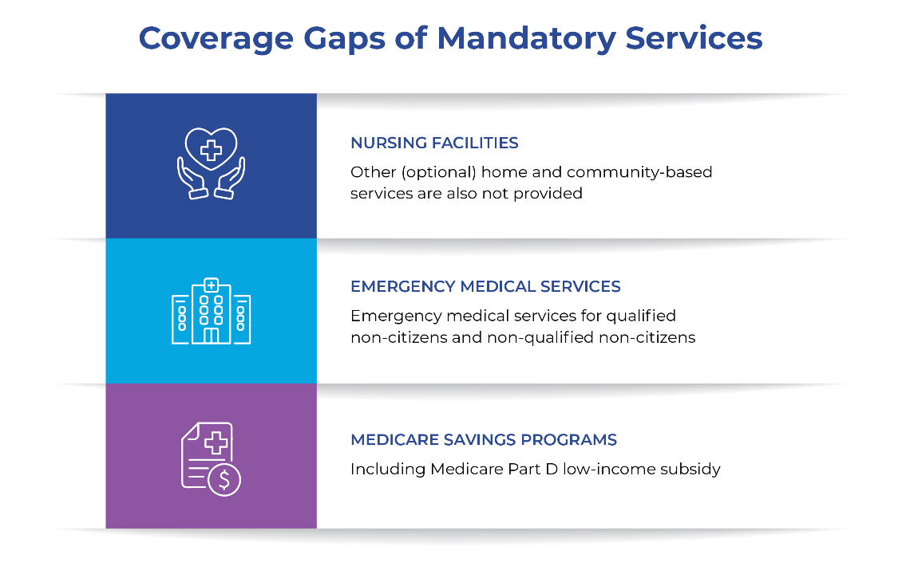
Figure 20: Coverage Gaps of Mandatory Services
* Lack of a Medicare Savings Program creates gaps in mandatory services not available in Puerto Rico.

Projected Medicaid Spending Under Different Funding Scenarios and Their Effects
To maintain current health care coverage levels, the FOMB’s 2024 Fiscal Plan projects total Medicaid Expenditures of $5.8 billion in FY 2028. However, this assumes a $500 million annual cap, Enhanced Allotment Program (EAP) funding (about $76 million), and CHIP funding (about $114 million) as the only available federal funding sources. Given its fiscal condition, it is highly unlikely that Puerto Rico could substantially increase its state Medicaid contribution. The FOMB recognizes that, “assuming that the Commonwealth would be responsible for the relevant costs under current law in the absence of incremental federal legislation, the resulting impact is significant out-year budget deficits.” Preliminary projections establish the basis for an initial federal funding request totaling $4.815 billion in FY 2028 based on FY 2027 total Medicaid program expenditures. This estimate would support the maintenance of the current program and services.
If federal Medicaid funding in FY 2028 is materially below projected program expenditures and local financing is not increased by the same amount, total Medicaid spending would have to decline. The scenarios below illustrate different combinations of federal and local financing, including a scenario in which Puerto Rico contributes only the amount required to draw the capped federal allocation at the 55% statutory FMAP.
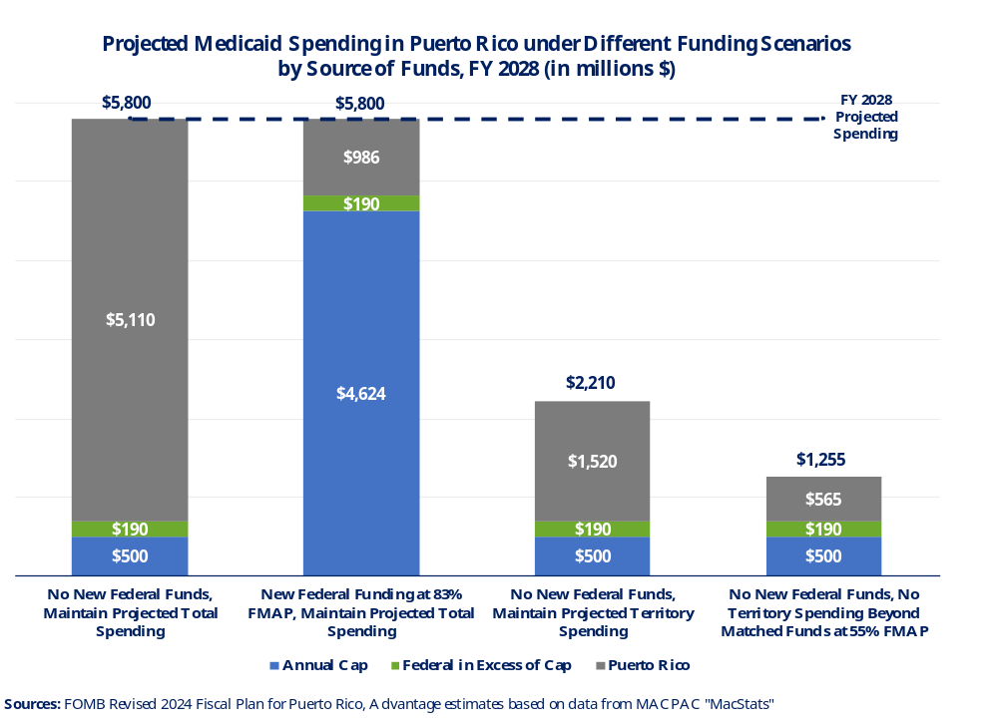

Figure 21: Projected Medicaid Spending in Puerto Rico Under Different
Funding Scenarios by Source of Funds, FY 2028
Reductions in Medicaid spending would have immediate implications for eligibility, covered benefits, and provider reimbursement, effectively overturning many of the recent health achievements. Based on past spending data, enrollment at the current level of benefits would need to decrease by approximately 860,000 to 1 million beneficiaries in FY 2028. Puerto Rico’s uninsured rate would rise sharply, from 5.7% in 2024 to approximately 30%.
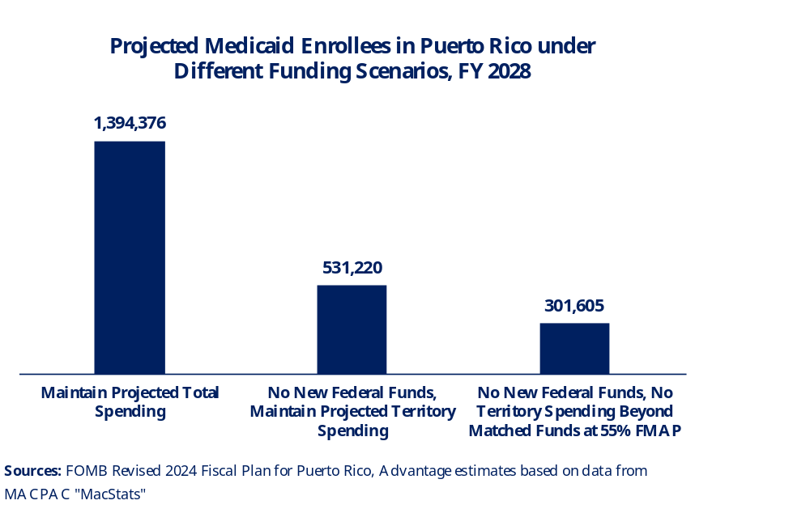
Figure 22: Projected Medicaid Enrollees in Puerto Rico under Different Funding Scenarios, FY 2028
Medicare and Medicaid: Consequences for Puerto Rico’s Health Care System
Hospitals
Since a large share of the population relies on both Medicare and Medicaid for health coverage and Puerto Rico operates a mostly managed care model, challenges tied to certain methodologies used under Medicare are particularly significant for island providers, insurers, and the Medicaid population. One example is the methodology used to determine the Medicare wage index for hospital payments, including the problem of circularity.
The wage index is used in Medicare’s hospital payment formula to adjust payments based on local labor costs. CMS calculates the area wage index annually and uses it to adjust Medicare standard payments to hospitals in the Inpatient Prospective Payment Systems (IPPS) to reflect the prices hospitals face in their local labor markets. The wage index is affected by a phenomenon known as circularity, whereby hospital wages influence Medicare payment adjustments, and those payments, in turn, constrain hospitals’ ability to raise wages.
Due to low reported wages on the island, the wage index has historically been lower than in the rest of the United States. The wage index of hospitals on the island ranks in the bottom quartile (the lowest 25%) among hospitals across the nation.

Table 10
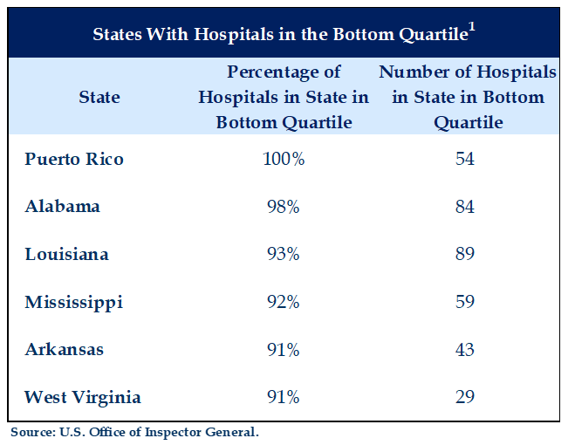
Web source: https://oig.hhs.gov/documents/audit/5895/A-01-20-00502-Complete%20Report.pdf

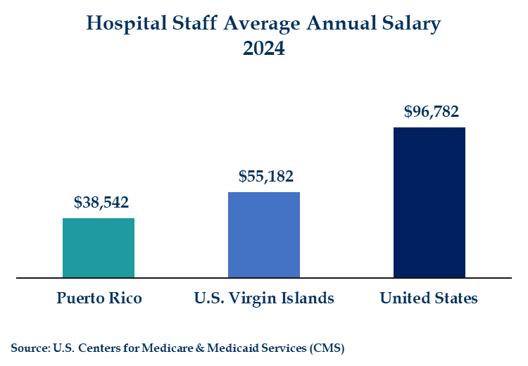
Figure 23: Hospital Staff Average Annual Salary 2024
Medicare Advantage (MA) covers most Medicare beneficiaries in Puerto Rico, and since hospitals depend heavily on payment for treating this population to maintain operations, having a low wage index can have broader negative consequences on the hospital system's financial condition.
MA county benchmarks, the maximum amount CMS will pay MA plans, are derived by using the national level Fee-For-Service (FFS) spending and applying a geographic factor adjustment reflecting differences in the average local spending. When FFS spending is suppressed by low wages, the MA benchmark is structurally lower, and plans pay hospitals relative to the lower starting point.
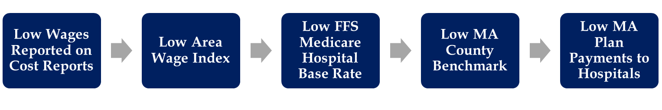
Because Medicare Advantage benchmarks are derived in part from local Original Medicare spending, the same low underlying FFS spending environment can affect both Original Medicare payments and MA benchmark calculations. The report therefore evaluates the interaction between the Medicare wage index, FFS spending, and MA financing alongside demographic growth in the population age 65 and older, which will result in a growing demand for hospitals, physicians, and specialized health services.
Table 11
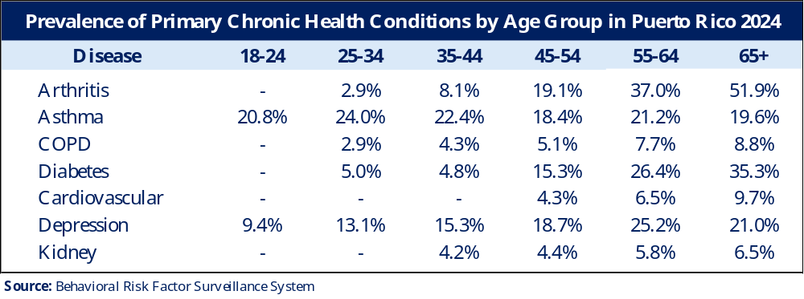
As Medicare participation increases, the CMS wage index could carry an even greater weight in the health care market. In other jurisdictions with high poverty levels, the wage index generally tracks or exceeds the salaries for all occupations when expressed as a ratio to national levels. This is not the case for Puerto Rico.

Figure 24: Wage Index vs. All Occupations: Comparison Between Selected States (2024)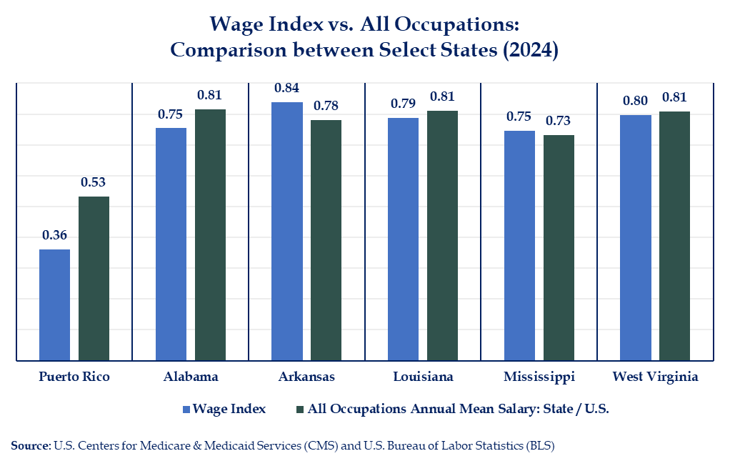
Sources: Wage Index Files https://www.cms.gov/medicare/payment/prospective-payment-systems/acute-inpatient-pps/wage-index-files | CMS and U.S. Bureau of Labor Statistics OEWS https://www.bls.gov/oes/tables.html
Puerto Rico stakeholders have raised concerns that the Medicare wage index methodology produces payment levels that do not fully reflect the island’s health care labor market and underestimates relative wage levels in the island’s health care sector and distorts Medicare hospital payments.
Staff Shortages
Compensation differences are one factor relevant to recruitment and retention of health care professionals nationally. Because many Puerto Rico providers are U.S.-trained and bilingual, mainland employment is a readily available alternative, offering substantially higher compensation. Although the rate of salary growth on the island has accelerated in recent years, the gap between Puerto Rico and the rest of the United States, including the U.S. Virgin Islands, remains substantial.
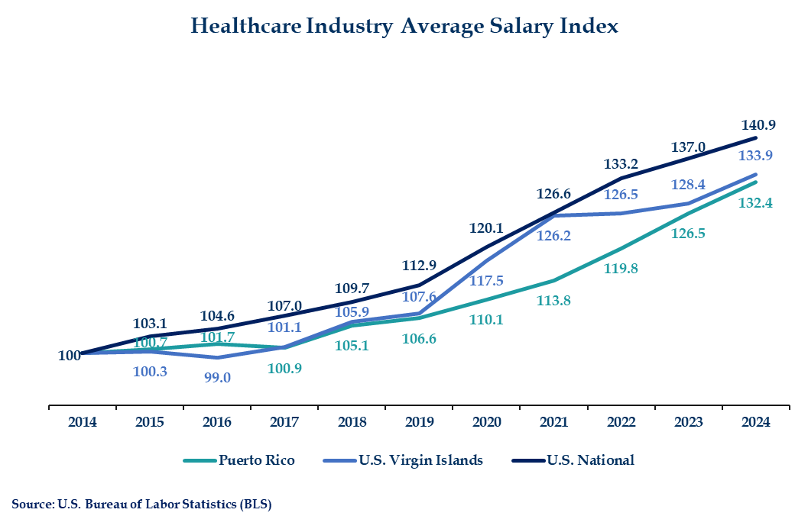
Figure 25: Health Care Industry Average Salary Index
Compensation aside, data from the American Medical Association (AMA) indicate that Puerto Rico has 245 direct patient-care physicians per 100,000 residents, compared with 254 in the United States. While this gap may appear modest, it becomes concerning when the island’s age profile is considered as medical professionals are older and reaching retirement age. The 2023 demographic profile indicates that 37.9% of Puerto Rico physicians are aged 65 and over, compared to 23.4% on the mainland. Furthermore, data published by the AMA also shows the number of hours worked by physician providers declines with age.
The following chart highlights some medical specialties in Puerto Rico with more than 35% of physicians being 65 years old and above:

Figure 26: Specialties in which more than 35% of physicians
are age 65 or older – Puerto Rico 2023
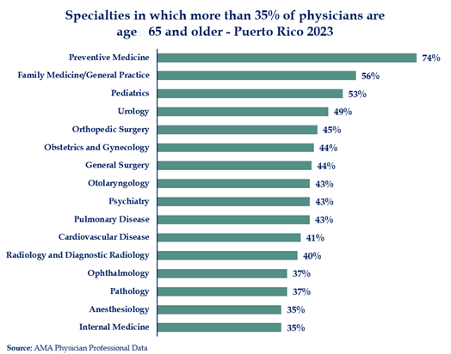
Puerto Rico’s population is aging, including its physician workforce. As the island faces increased demand for services alongside a reduced effective supply of doctors, significant issues may arise in critical health system specialties. Extended waiting times for specialty care are increasingly common across the island, with patients often waiting months for available appointments. If unaddressed, the imbalance between population health needs and the availability of specialists and subspecialists may evolve into a broader health crisis in Puerto Rico.
Medical residencies in Puerto Rico
Despite the challenges created by the Medicare wage index and the financial pressures affecting hospitals, Puerto Rico has demonstrated strong performance in its residency training programs. Graduate medical education plays an important role in strengthening workforce and addressing physician shortages on the island.
An important indicator of the success and potential of local residency programs is the physician retention rate following completion of training. In 2023, 76% of medical residents who completed their training in Puerto Rico chose to remain there to practice medicine.
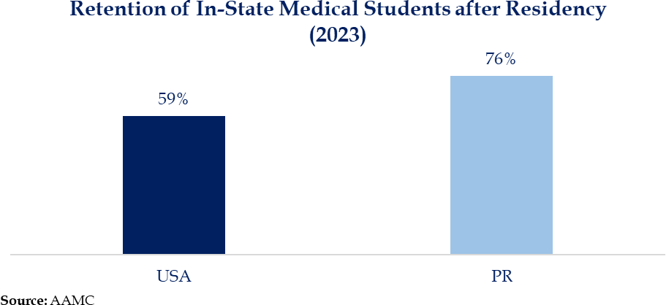

Figure 27: Retention of In-State Medical Students after Residency (2023)
While Puerto Rico has demonstrated strong performance in physician retention through its residency programs, failure to address the structural limitations of the Medicare wage index could undermine these gains over time. If reimbursement levels continue falling behind labor market realities, hospitals may face increasing financial constraints that limit their ability to offer competitive compensation, potentially impacting future physician retention rates.
These financing pressures are further compounded by Puerto Rico’s unique Medicare market, where most beneficiaries receive coverage through Medicare Advantage.

Medicare Advantage
Recent enrollment data show that over 680,000 seniors in Puerto Rico are enrolled in MA plans. Yet, the rate benchmarks used to determine MA payments rely on spending under Original Medicare, which reflects claims submitted by approximately 29,000 beneficiaries enrolled in both Part A and Part B. Payment rates in Puerto Rico ($778) are thus 20% lower than in the U.S. Virgin Islands ($967), and 40% lower than the national average ($1,299). This methodology does not fully capture MA utilization or the cost of providing services in a jurisdiction with a large elderly population and a high prevalence of chronic diseases.

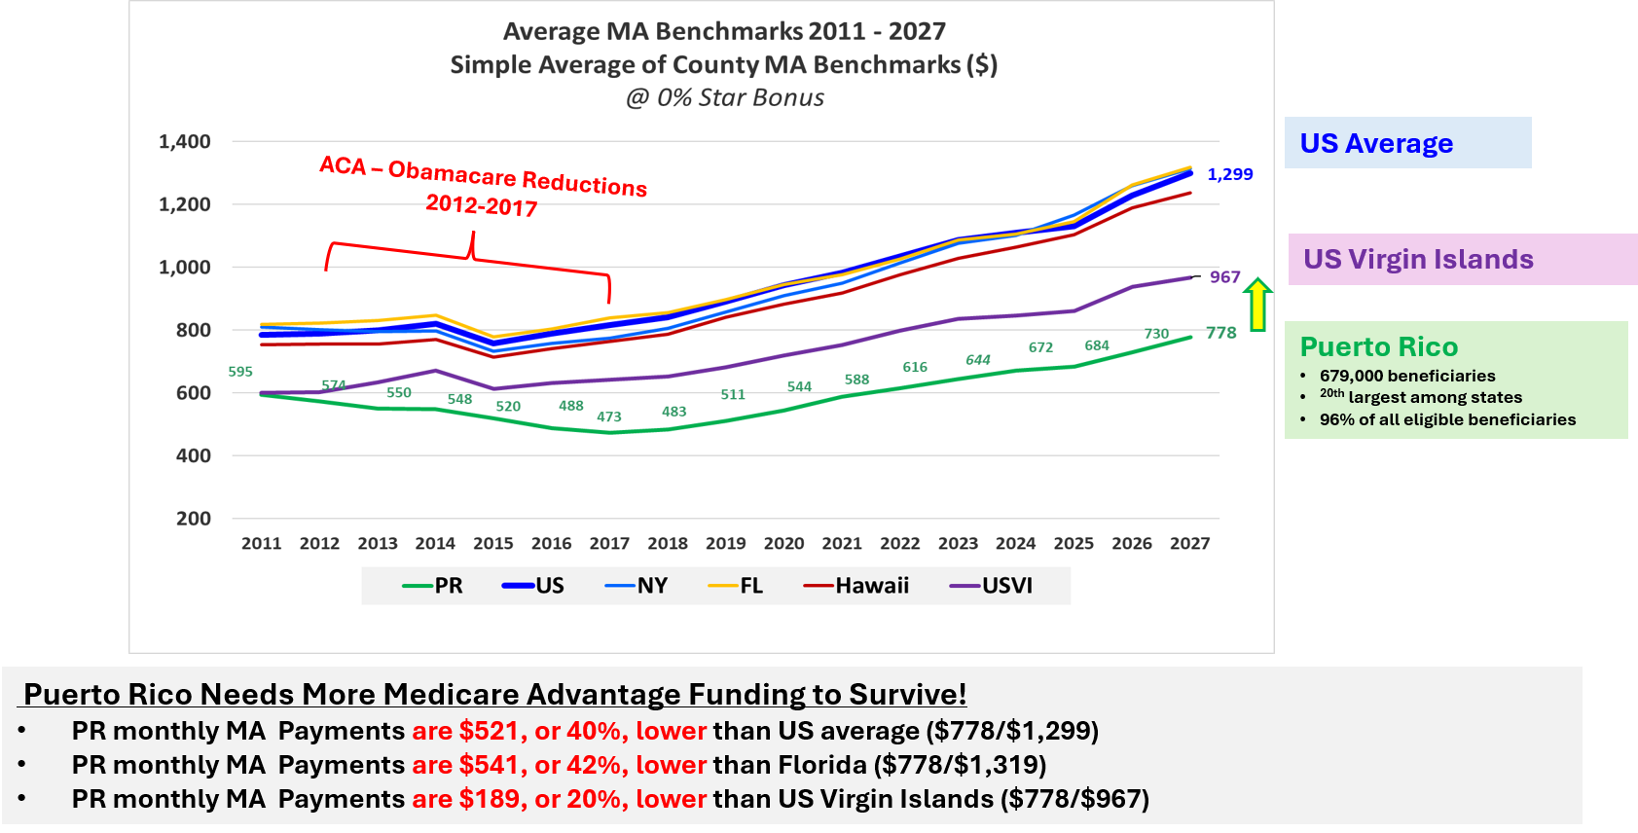
Figure 28: Average MA Benchmarks 2011-2027
CMS’s Calendar Year (CY) 2027 Rate Announcement continued Puerto Rico-specific adjustments in the Medicare Advantage rate methodology and included an increase of 4.01% for Puerto Rico, compared with the national increase of 2.48%. While this was a step in the right direction, an annual payment-policy result is not tantamount to a permanent resolution of the underlying methodology. Puerto Rico will continue working with the Administration and Congress to secure a suitable and permanent fix in the years ahead, starting with the pending CY 2028 announcement.
MA plans in Puerto Rico show consistent quality performance, with every beneficiary enrolled in a plan holding a CMS star rating of 4.5 or higher. The island needs access to suitable resources to continue this positive trend and provide the best care for our seniors. As such, Puerto Rico has requested an administrative fix by HHS for the MA benchmarks in CY 2028 and use the MA benchmarks of the U.S. Virgin Islands as a proxy for Puerto Rico. This proposal has been supported by health care stakeholders, and by dozens of Members of Congress as a bipartisan request to HHS and CMS.
Pharmacies

Pharmacy is the largest expense category. The rising costs of pharmaceutical drugs pose significant challenges. Unlike other inputs in the health care system, prescription drug costs in Puerto Rico are largely aligned with prices in the rest of the United States. These costs are particularly challenging for pharmacy providers in Puerto Rico, which operate within a lower-revenue health market.
The significance of specialty drugs within the pharmaceutical market is also growing. Specialty drug sales increased by 67% over the same period and, by 2025, represented 53% of total prescription drug sales.

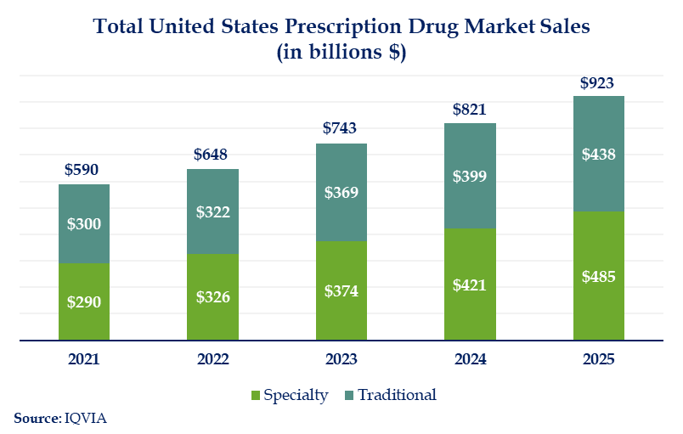

Figure 29: Total United States Prescription Drug Market Sales

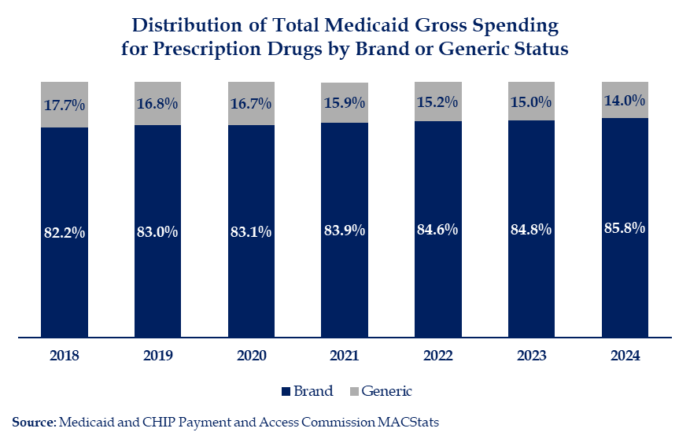

Figure 30: Distribution of Total Medicaid Gross Spending
for Prescription Drugs by Brand or Generic Status
Average spending per brand drug claim has increased substantially. This is in part due to the emergence of high-cost and specialty drugs, such as GLP-1s, cell and gene therapies, as well as cancer treatments. Puerto Rico was the fastest-growing U.S. jurisdiction for GLP-1 electronic prescriptions in 2025, with a 74.2% increase relative to the previous year.
Due to limited funds, certain drugs that are covered by Medicaid programs on the mainland are not available to Puerto Rico residents. Challenges with medicine costs are exacerbated due to the high level of pharmaceutical consumption consistent with greater medical needs. Diabetes, autoimmune, and oncology are some of the largest therapeutic areas in the market, each experiencing sales volume increases from 8% to 20%.
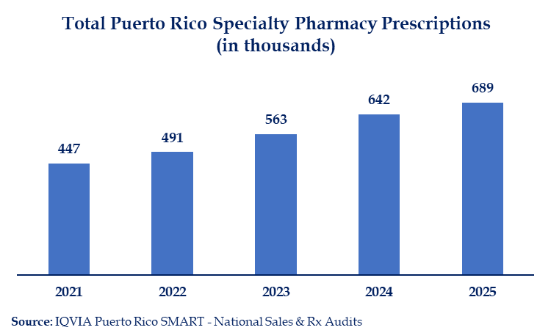
Figure 31: Total Puerto Rico Specialty Pharmacy Prescriptions
Federally Qualified Health Centers and Laboratories

Federally Qualified Health Centers (FQHCs) are another key component in Puerto Rico’s health care system. They have been providing primary and preventive medical care to disadvantaged communities since 1971. These centers receive federal funding, improving access to health care for thousands in Puerto Rico, regardless of their ability to pay or have insurance. They are a key part of meeting the needs of vulnerable populations in Puerto Rico.

In 2025, primary care centers in Puerto Rico served 508,068 patients, of whom 6 out of every 10 were enrolled in Medicaid. This amounts to 22% of all Medicaid enrollees in Puerto Rico. They also treat a substantial number of Medicare and uninsured patients.

The tables and percentages below break down the percentage of Medicaid patients treated by FQHCs and their multiple sites across the island.
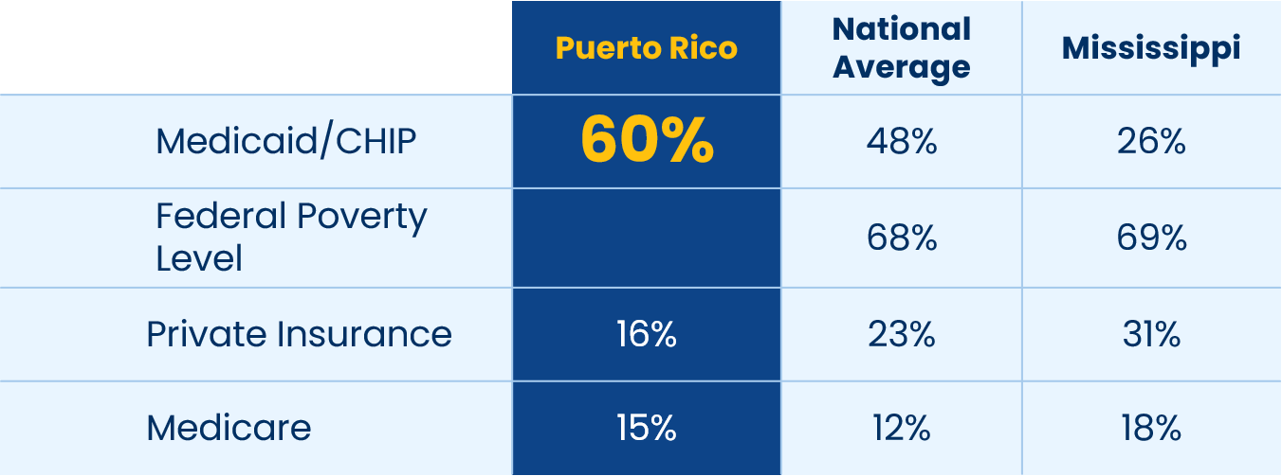

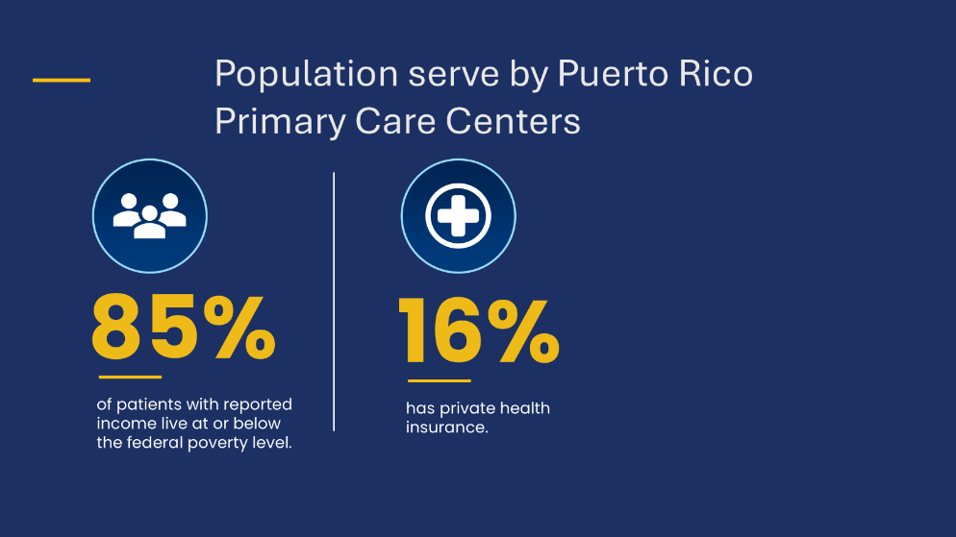

Laboratories are another critical component of Puerto Rico’s health care system. Given the high prevalence of chronic conditions on the island, laboratory testing plays an essential role in early detection, diagnosis, ongoing disease management, and determining appropriate treatment. Reliable access to laboratory services also enables providers to monitor treatment effectiveness and make timely adjustments to patient care. Securing adequate Medicaid funding beyond FY 2027 would help sustain the network of laboratories serving Plan Vital beneficiaries across Puerto Rico and preserve access to these essential diagnostic services.

Future Challenges of Medicaid Funding and FMAP
Medicaid funds provided over the last three fiscal years have been distributed among providers in a fair manner, based on the trends and cost of medical expenses on the island. Nevertheless, insufficient funding continues to limit Puerto Rico’s ability to reimburse providers at levels comparable to those in the states.
The following table shows the distribution of Medicaid medical expenditures by service category. Moving forward, the program must continue to sustain and enhance its efforts to ensure adequate reimbursement for services rendered. Strengthening reimbursement mechanisms will help maintain the availability of essential provider types and support a stable health care network across the island.

Table 12
Medical Expense Distribution
Pharmacy | 34%
Specialists | 15%
Hospital IP | 13%
Primary Care Groups | 6%
Laboratory/Radiology | 6%
Outpatient Services | 6%
Emergency Room | 5%
Hospital OP | 3%
Dental | 3%
FQHC (330) | 1%
Sub-Capitated Claims - PCPs | 8%
Grand Total | 100%

The enhanced federal allotments and elevated 76% FMAP are scheduled to expire in FY 2028. Assuming current spending patterns, the island would revert to a statutory annual base cap of about $500 million with limited supplemental funding and a 55% FMAP. Federal participation would effectively decline to no more than 20% of total Medicaid expenditures, much lower than any other territory or state.

Table 13
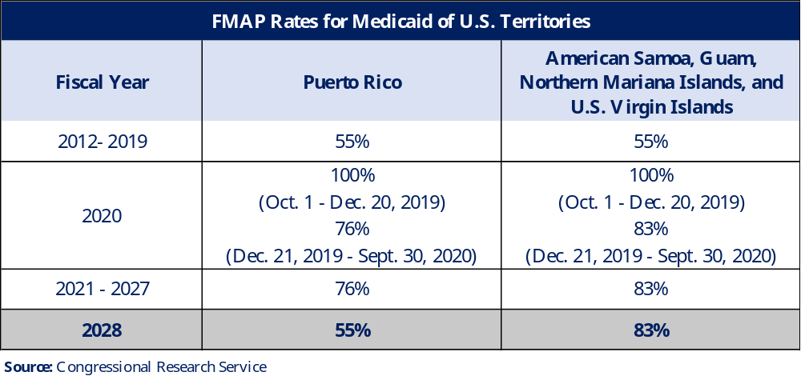

Puerto Rico’s Unique Circumstances
This funding shift could occur in a fiscal context still shaped by years of austerity, debt restructuring, and constrained revenue growth.
In 2016, Puerto Rico faced an unsustainable burden of more than $72 billion in public debt and over $55 billion in unfunded pension liabilities, due to a profound economic downturn and structural imbalances between revenues and expenditures. The government had routinely borrowed money to pay for public services, including Medicaid contributions, by issuing municipal bonds, culminating in defaults and the loss of access to capital markets.
Congress later enacted the Puerto Rico Oversight, Management, and Economic Stability Act (PROMESA), Public Law 114-187, to “meet Puerto Rico’s immediate need to provide its citizens effective services, formulate a debt restructuring, and implement fiscal reform leading to a sustainable economy, fiscal responsibility, and market access”.
PROMESA established a federally appointed Financial Oversight and Management Board (FOMB) and requires fiscal plans and budgets that satisfy statutory requirements and are certified by the FOMB. These plans have imposed strict, mandatory budgetary constraints which require any proposed increase in the local Medicaid contribution to be evaluated within that federally established fiscal framework.
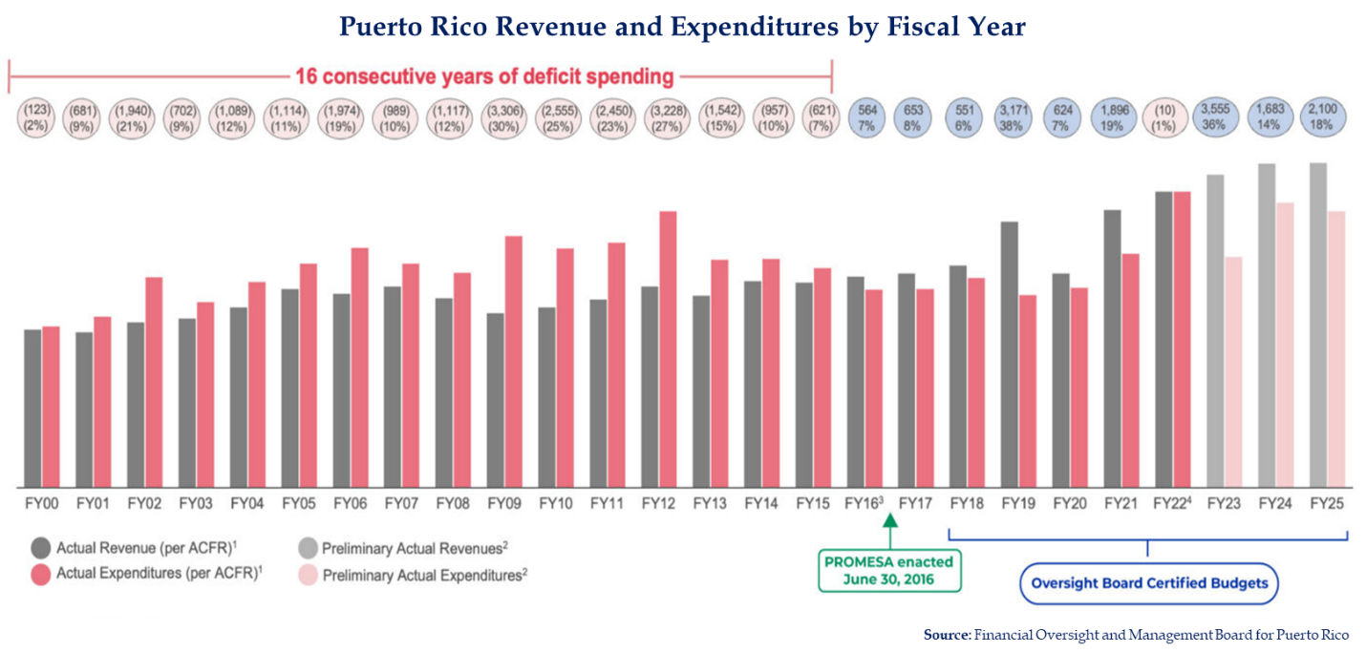Figure 32: Puerto Rico Revenue and Expenditures by Fiscal Year
Puerto Rico officially exited bankruptcy in March 2022, completing the largest public debt restructuring in U.S. history, except for the Puerto Rico Electric Power Authority, currently under PROMESA’s Title III process. A central component of this restructuring is the implementation of the Pay-As-You-Go (PayGo) pension financing system, which requires the central government to directly finance pension obligations for legacy public employees, including teachers and police officers. Under PayGo, pension payments are an immediate, recurring operating expense that places significant pressure on and limits the annual budgets of the central government, public agencies, and municipalities required to contribute.
Furthermore, pension benefits do not include automatic cost-of-living adjustments, eroding the purchasing power of retirees over time. It is worth noting that this has implications for health and well-being, as a smaller share of fixed income is available for health care-related expenses, including medications, copayments, and preventive services. Drastic monthly premium increases or benefit reductions due to funding losses would leave retirees especially vulnerable.
A reduction in the federal allotment and FMAP could also have further implications for municipal governments. In accordance with local Act 72-1993, the municipalities of Puerto Rico are responsible for collecting and remitting payments to PRHIA to help finance the Medicaid program. Historically, municipalities were required to contribute about $164 million annually.
In 2018, an agreement was reached to adjust this contribution in response to changes in federal Medicaid financing, particularly in years when the FMAP exceeded the statutory 55% under which the law was developed. Under this revised framework, the municipal contribution was reduced to approximately $85 million starting FY 2024.
The adjustment functions as an important fiscal relief mechanism for municipalities, many of which continue to operate under persistent deficits and limited revenue bases. If the FMAP were to revert to the statutory 55% baseline, municipalities would likely be required to restore prior contribution levels, compromising their financial flexibility. Such a shift could force trade-offs between supporting Medicaid and providing other essential services.
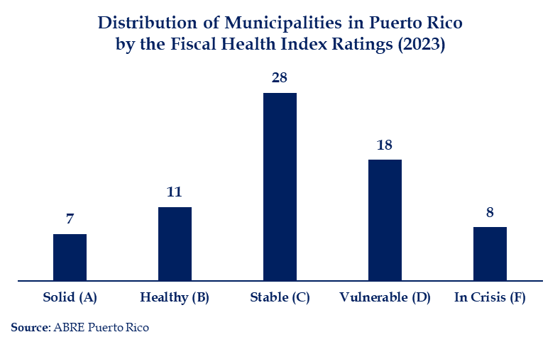

Figure 33: Distribution of Municipalities in Puerto Rico by the
Fiscal Health Index Ratings (2023)

Limited Ability to Generate Tax Revenue to Cover Local Share
Individual income tax is a primary source of funding for public expenditures, accounting for about 22% of General Fund revenues. However, personal income tax revenues are projected to remain structurally constrained, with limited growth in comparison to other states.
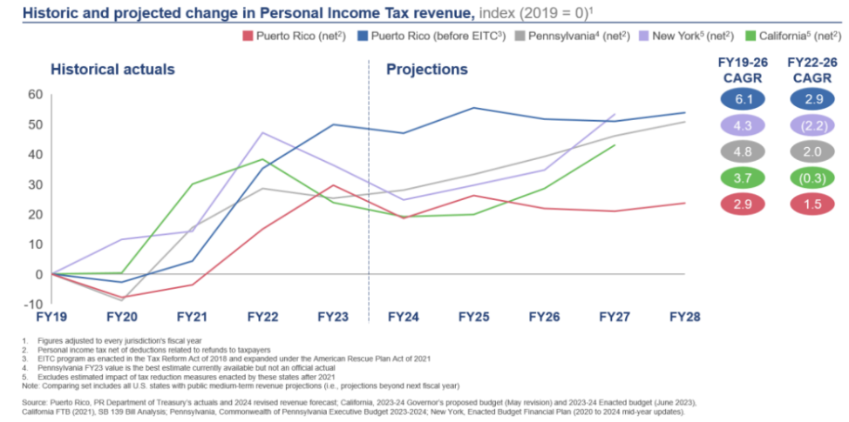

Figure 34: Historic and Projected Change in Personal Income Tax Revenue
These fiscal constraints are closely linked to underlying socioeconomic and demographic trends. High poverty rates compress the taxable income base. In 2023, those who reported income of up to $40,000 (around 467,000 taxpayers) contributed only 9.2% of total individual income tax revenue. The system is dependent on taxpayers with incomes above $100,000, who contributed more than 62.2% of total revenue.
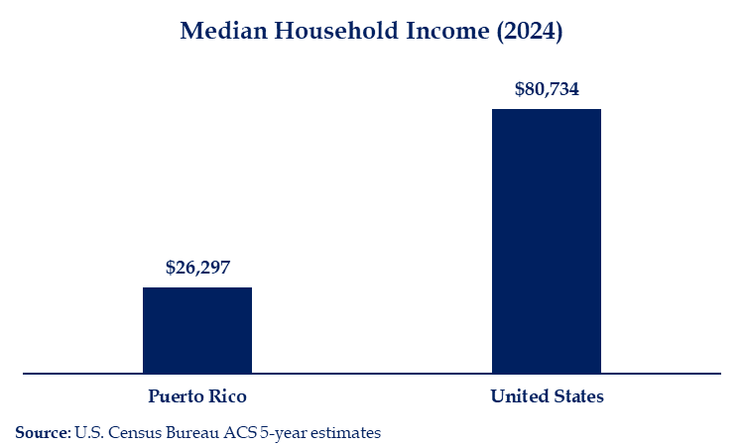

Figure 35: Median Household Income (2024)

Impact of FMAP and Allotment Reductions: A Funding Cliff

The change scheduled under current law after FY 2027 would reduce both Puerto Rico’s federal allotment and its FMAP relative to the temporary CAA 2023 framework, creating a situation where access and quality would be severely reduced.

Puerto Rico would revert to 55% FMAP and reduced allotment. The allotment would be recalculated based on the FY 2019 cap, adjusted for inflation to the medical component of the Consumer Price Index for All Urban Consumers (CPI-U), without accounting for increased funding received from FY 2020 to FY 2027., Based on this methodology, and assuming medical CPI-U growth of approximately 3% per year, the FY 2028 allotment is estimated to fall below $500 million, compared to approximately $3.825 billion under current law.

If the CAA 2023 FMAP and annual capped allotment levels are not sustained or increased, Puerto Rico would need to consider Medicaid reductions, which could include rolling back service, eligibility, and provider rate enhancements depending on the size of the federal financial reduction. The island would almost certainly need to try to roll back the services it implemented in 2024—home health, DME, NEMT, and hospice care. All, except hospice care, are considered mandatory services, and CMS might not approve removing them as covered services.

CMS not approving the elimination of these services would put the island at significant risk of having to fund services exclusively with state funds once the cap is exceeded. Additionally, Puerto Rico might have to stop covering the newly implemented Medicaid-funded school-based services. As previously noted, EPSDT requires all services that can be covered under the State Plan to be provided to beneficiaries under 21 years old. However, other optional services for adults would also have to be considered for elimination, which include physical, occupational, and speech therapy, dental services, and prosthetics.

A reduction of approximately $3.36 billion in annual federal funding would require a combination of higher local funding and lower Medicaid expenditures, which would have a disproportionate impact on the population with chronic conditions, whose health care costs are higher.

Additionally, if PRMP must undo the provider rate increases, access will be at risk. According to information published in September 2024 by the Puerto Rico Medical Defense Insurance Company, the number of physician licenses issued increased slightly, although the number of specialists dropped. Rolling back increases could risk undoing even these modest gains.
Medicaid funds flow directly into Puerto Rico’s health care sector, supporting hospitals, doctors’ offices, pharmacies, and other providers. A federal funding shortfall would shrink revenue for these entities, forcing service reductions, job cuts, and fewer purchases and investments. The effects ripple across their supply chains, affecting other businesses, such as medical equipment suppliers and food producers, who must adjust operations amid declining demand. As workers lose their jobs and income, they must reduce their spending on consumer goods and services, further amplifying the initial contraction.
In addition, the decline in economic activity would translate into lower tax revenues for the government of Puerto Rico and municipalities, including sales and use, individual income, and corporate income taxes.

Congressional Engagement and Bipartisanship:

A United Front

Engagement with key decision-makers based on a clear, verifiable factual record is essential to ensure effective Congressional and administrative action in advance of FY2028. Efforts need to be directed toward members and staff from both sides of the aisle by a bipartisan team, representing a wide array of interests: beneficiary advocates, providers, MCOs, and government representatives.

Puerto Rico must approach Congress with a clear and unified message that includes the concerns outlined in this report:
- Explain the funding limitations and uncertainties.
- Describe and provide evidence of the consequences of these limitations, both at the community and individual levels.
- Describe and provide evidence of the adverse consequences if Puerto Rico hits the funding cliff and enhanced funding is not renewed.
- Explain that, while the most critical action is to prevent the funding cliff, the best path forward is equitable state-like funding.
- Share with decision-makers that Puerto Rico is meeting its obligations under the CAA 2023 and will continue to ensure responsible stewardship of federal Medicaid funding.

The approach can take two paths simultaneously:
- Outline the policy, fiscal issues, and implications.
- Support this information with evidence of the impact on individuals.

On the policy side, advocates should also engage with national stakeholders. The creation of the Multisectoral Advisory Board is a key step toward a strategic, coordinated approach to Congressional advocacy.

Similarly, the Advisory Board should continue engaging with stakeholders, in collaboration with Puerto Rico state agencies, to advocate for administrative action by CMS that improves the payment rate utilized for MA plans operating on the island.

Stakeholder participation can supplement the quantitative record with documented beneficiary and provider experience. Individual examples should be used to illustrate specific access or program-design issues and should not substitute for representative data or independently support claims about island-wide effects.

Conclusion

The PRMP operates under a distinct and challenging set of circumstances. It must respond to national federal expectations regarding program oversight, managed care accountability, and quality measurement, while navigating a financing structure that limits its ability to maintain or expand services and sustain provider reimbursement at levels that support beneficiary access.

The implications of the structural funding disparities documented in this report go beyond administrative concerns and shape the broader health care market operating within Puerto Rico. Financing limitations influence managed care participation, provider network stability, pharmaceutical access, and the ability to implement long-term population health strategies. While the island must meet federal programmatic expectations, it is required to operate within a fundamentally different financing framework compared with the states. Addressing these structural issues will require coordinated federal policy that aligns Puerto Rico’s Medicaid financing structure with that of the states.

The report identifies two primary objectives. In the near term, the priority is to address the anticipated change in federal Medicaid financing beginning in FY 2028. Over the long term, the preferred approach is to remove the §1108 allotment ceiling and apply the same FMAP formula used for the states. If Congress instead maintains a funding cap, an alternative approach would be to establish an allotment sufficient to sustain existing program services while providing targeted funding to expand access to services that are currently unavailable or limited in Puerto Rico, including long-term services and supports and assistance with Medicare Part B premiums and cost sharing for eligible low-income beneficiaries.
Absent Congressional action, federal spending in Puerto Rico could decrease by close to $3.36 billion, starting in FY 2028. A funding reduction of this scale would represent a significant negative shock to the broader local economy. Puerto Rico’s request for action from Congress is:
      - Remove the allotment ceiling, consistent with state Medicaid programs, to provide adequate, sustained funding to Puerto Rico;
      - Utilize the same formula as the states to determine the FMAP, which would likely result in an FMAP of 83%. However, increasing the FMAP without increasing the allotment would only result in Puerto Rico exhausting its allotment faster;
- Include Puerto Rico in other federal programs from which it is currently excluded, like disproportionate share payments for hospitals to help address uncompensated or under-compensated care and, once sufficient funds are available, the Medicare Savings Program, which helps pay Medicare premiums and cost-sharing; and
- Extend access to Long-Term Services and Supports (LTSS). Should sufficient funding not become available for Puerto Rico to establish LTSS island-wide, Congress could consider providing funds for a regional pilot program. This would allow the island to focus long-term services in certain areas while still controlling federal spending.

Puerto Rico continues to implement and explore options for program improvements that strengthen administrative processes and help ensure low-income residents can access Medicaid benefits. PRMP remains committed to maturing the program through strengthening governance, developing technological capacity and infrastructure, improving program oversight, and increasing program transparency practices in strong collaboration with state and federal partners.

See appendix for detailed stakeholder contributions.
Puerto Rico does not operate a separate Children’s Health Insurance Program (CHIP). Instead, CHIP coverage is provided through Medicaid Expansion CHIP, which is administered through the Medicaid program and receives an enhanced federal matching rate through Title XXI of the SSA; therefore, references to Medicaid include both Medicaid (Title XIX of the SSA) and CHIP (Title XXI).
CMS Medicare Monthly Enrollment. April 2026. https://data.cms.gov/summary-statistics-on-beneficiary-enrollment/medicare-and-medicaid-reports/medicare-monthly-enrollment
Medicaid and Medicare Advantage Association. September 2023. “Modern Healthcare: Puerto Rico: The ‘canary in the coal mine’ for Medicare Advantage growth.”
America Counts Staff. August 25, 2021. "Puerto Rico Population Declined 11.8% From 2010 to 2020." United States Census Bureau. Accessed April 6, 2026. https://www.census.gov/library/stories/state-by-state/puerto-rico.html#age
Ibid.
Amílcar Matos-Moreno, Ashton M Verdery, Carlos F Mendes de Leon, Vivianna M De Jesús-Monge, and Alexis R Santos-Lozada. June 13, 2022. Aging and the Left Behind: Puerto Rico and Its Unconventional Rapid Aging. The Gerontologist. Accessed October 2, 2025. https://pmc.ncbi.nlm.nih.gov/articles/PMC9372893/
United Nations Department of Economic and Social Affairs Population Division. World Population Prospects 2024.
U.S. Centers for Disease Control and Prevention. January 29, 2025. "BRFSS Prevalence & Trends Data." U.S. Centers for Disease Control and Prevention.
Ibid.
SSI Federal Payment Amounts For 2026. https://www.ssa.gov/oact/cola/SSI.html
Puerto Rico Medical Defense Insurance Co. “Market Research: Medical Practice in Puerto Rico.” September 2024. https://estadisticas.pr/files/BibliotecaVirtualPrivado/Estudio_de_Mercado_Practica_Medica_en_Puerto_Rico.pdf
Puerto Rico Central Cancer Registry. https://mapas.rcpr.org
Ipsos. 2024. “Demographic Challenge in Puerto Rico.” https://camarapr.org/wp-content/uploads/Puerto-Ricans-living-in-the-USA.pdf
Missouri Economic Research & Information Center. 2026. “Cost of Living Data Series.” https://meric.mo.gov/data/cost-living-data-series
MACPAC. February 2026. “EXHIBIT 23. Medicaid Benefit Spending per Full-Year Equivalent Enrollee for Newly Eligible Adult and All Enrollees by State.” EXHIBIT-23.-Medicaid-Benefit-Spending-per-Full-Year-Equivalent-Enrollee-for-Newly-Eligible-Adult-and-All-Enrollees-by-State-FY-2024.xlsx
These estimates do not represent actual Medicaid enrollment among individuals who relocated.
L. Merling and J. Johnston. October 2017. “More Trouble Ahead: Puerto Rico’s Impending Medicaid Crisis.” Center for Economic Policy and Research. https://cepr.net/images/stories/reports/puerto-rico-medicaid-2017-10.pdf
Consolidated Appropriations Act, 2023, Pub. L. No. 117‑328, 136 Stat. 4459 (2022); Social Security Act §1905(b), 42 U.S.C. §1396d(b).
Consolidated Appropriations Act, 2023 (Pub. L. No. 117-328).
In addition to these amounts, Puerto Rico is also eligible to receive up to $375 million contingent on compliance with certain integrity measures and increases in provider payments. The island has consistently complied, and has received these funds annually, which brings the total amount for FY 2027 to $4.2 billion.
April 2026 FY 2023-2025 Federal Expenditures vs Allotment from Milliman.
Details about the cost of these added services are included in a separate section of the report.
Sections 5101(a) and 5101(b) of the Consolidated Appropriations Act, 2023 amended Social Security Act Section 1108(g) (42 U.S.C. §1308(g)).
Consolidated Appropriations Act, 2023 (Pub. L. No. 117-328).
Consolidated Appropriations Act, 2023 (Pub. L. No. 117-328).
Social Security Act §1108(g)(7)(A)(i), 42 U.S.C. §1308(g)(7)(A)(i).
Consolidated Appropriations Act, 2023 (Pub. L. No. 117-328); Social Security Act §1108(g)(9), 42 U.S.C. §1308(g)(9).
State and Federal expenditures.
Financial Oversight & Management Board for Puerto Rico. (June 2025). Revised 2024 Fiscal Plan for Puerto Rico Restoring Growth and Prosperity.
Ibid.
Ibid.
U.S. Census Bureau ACS 5-year estimates.
Currently, close to 307,000 residents on the island are dually eligible under Medicare and Medicaid and enrolled in a Plan Platino, offered through MA plans currently operating in Puerto Rico.
U.S. Office of Inspector General. December 2020. “The Centers for Medicare & Medicaid Services Could Improve Its Wage Index Adjustment for Hospitals in Areas with the Lowest Wages.”
Puerto Rico currently has 66 operating hospitals.
Congressional Research Service. March 2026. “Medicare Advantage: Proposed Benchmark Update and Other Adjustments for CY2027 in Brief.”
American Medical Association. January 6, 2025. “How many hours are in the average physician workweek?” https://www.ama-assn.org/practice-management/physician-health/how-many-hours-are-average-physician-workweek
Medicaid and Medicare Advantage Products Association of Puerto Rico. Press Release. August 7, 2026. “Unprecedented Support from Republican Members of Congress to Strengthen Medicare Advantage Funding in Puerto Rico”. https://www.mmapapr.org/post/14-house-republicans-urge-medicare-advantage-payment-action-for-puerto-rico.
Medicaid and Medicare Advantage Association. April 2026. “Medicare Advantage 2027: A Temporary Relief That Demands Long-Term Solutions.”
KFF. March 2026. Recent Trends in Medicaid Outpatient Prescription Drugs and Spending.
News is my Business. March 2026. “Puerto Rico leads U.S. growth in GLP-1 prescriptions in 2025.”
Dan O’Brien. 2026. 2025 Puerto Rico Pharmaceutical Year-in-Review. IQVIA. https://piapr.org/wp-content/uploads/2026/03/IQVIA-Puerto-Rico-2025-Pharmaceutical-Year-in-Review-PIA-032026.pdf
Health Center Program Uniform Data System (UDS) Data, Bureau of Primary Health Care, Health Resources and Services Administration, U.S. Department of Health and Human Services, 2025
Urban Institute. January 2017. “Puerto Rico Health Care Infrastructure Assessment.”
Disclosure Statement for the Third Amended Title III Joint Plan of Adjustment of the Commonwealth of Puerto Rico, et al.
Financial Oversight & Management Board for Puerto Rico. https://oversightboard.pr.gov/debt/
Financial Oversight and Management Board for Puerto Rico. 2025. “Fiscal Plan for the Municipal Revenue Collection Center.”
Per the 2023 report, this analysis excludes 6 municipalities that did not publish their financial statements for 2023. https://www.abretumunicipio.org
Carrión-Tavarez, Á. & Ríos, E.R. (October 2025). Taxes in Puerto Rico: Structure, Tax Burden, and Comparison with the United States.
Akash Pillai, Drishti Pillai, Samantha Artiga, and Robin Rudowitz. October 28, 2024. "Recent Changes in Medicaid Financing in Puerto Rico and Other U.S. Territories." KFF. Accessed April 6, 2026. https://www.kff.org/elections/recent-changes-in-medicaid-financing-in-puerto-rico-and-other-u-s-territories/
Consolidated Appropriations Act, 2023 (Pub. L. No. 117-328).
U.S. Bureau of Labor Statistics via Federal Reserve Bank of St. Louis (FRED). April 10, 2026. "Consumer Price Index for All Urban Consumers: Medical Care in U.S. City Average." Federal Reserve Bank of St. Louis. Accessed May 1, 2026. https://fred.stlouisfed.org/series/CPIMEDSL
Puerto Rico Medical Defense Insurance Co. “Market Research: Medical Practice in Puerto Rico.” September 2024. https://estadisticas.pr/files/BibliotecaVirtualPrivado/Estudio_de_Mercado_Practica_Medica_en_Puerto_Rico.pdf

